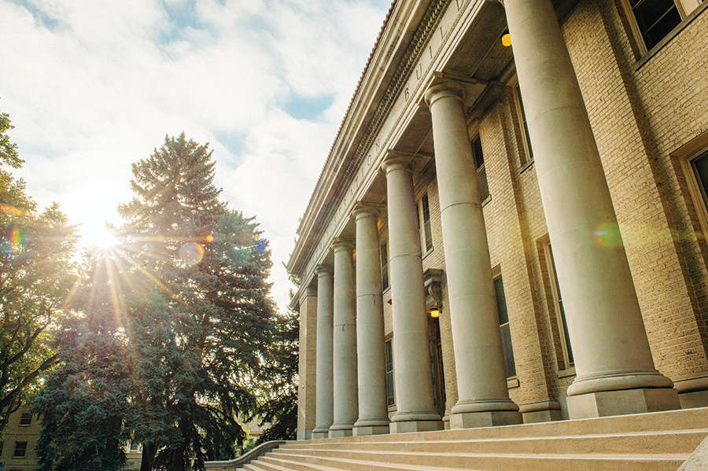

_______________________________

Division

of Student Affairs

Annual Report

2016-17

_______________________________

Annual Report
2016-17
Message from Dr. Blanche Hughes,
Vice President for Student Affairs
I am pleased to provide this annual report of the Division of Student Affairs of our activities and accomplishments. This past year has been significant for Student Affairs with the implementation of several new initiatives that are detailed in the annual report. We are especially appreciative of the collaborative and cooperative efforts of our colleagues on campus and in the Fort Collins community.
The Division provides a variety of programs and services designed to help students succeed and grow. The effectiveness and improvement of these programs and services are detailed under the following University Strategic Goals:
Goal 1: Access – Deliver on the Commitment to Inclusive Access
Goal 2: High Quality Academic and Co-Curricular Programs
Goal 3: Student Learning Success
Goal 4: Research and Discovery
Goal 5: Engagement
Goal 6: Public Interaction / Strategic Partnerships
Goal 7: Excellence Hiring, Professional Development, Employee Engagement
Goal 8: Diversity, Equity and Campus Climate
Goal 9: Financial Resources
Goal 10: Physical Resources
Goal 11: Information Management

The report concludes with an interesting array of Student Affairs honors and recognitions from the past year.

You can view this Annual Report online at the Division of Student Affairs Home Page at http://www.studentaffairs.colostate.edu/.
Sincerely,
Blanche Hughes, Ph.D.
Vice President,
Division of Student Affairs
201 Administration Building
Colorado State University
Fort Collins, CO 80523
Phone: (970) 491-5312
Table of Contents

Message from Dr. Blanche Hughes, Vice President for Student Affairs . . . . . . . . . . . . . . . . . . . . . . . . . . . 2
Mission, Brand Promise and Strategic Goals. . . . . . . . . . . . . . . . . . . . . . . . . . . . . . . . . . . . . . . . . . . . . . . . . 3
University Strategic Goals
- Goal 1: Access – Deliver on the Commitment to Inclusive Access. . . . . . . . . . . . . . . . . . . . . . . . .7

- Goal 2: High Quality Academic and Co-Curricular Programs. . . . . . . . . . . . . . . . . . . . . . . . . . . . 10

- Goal 3: Student Learning Success. . . . . . . . . . . . . . . . . . . . . . . . . . . . . . . . . . . . . . . . . . . . . . . . . .17

- Goal 4: Research and Discover. . . . . . . . . . . . . . . . . . . . . . . . . . . . . . . . . . . . . . . . . . . . . . . . . . . . 27

- Goal 5: Engagement. . . . . . . . . . . . . . . . . . . . . . . . . . . . . . . . . . . . . . . . . . . . . . . . . . . . . . . . . . . . .28

- Goal 6: Public Interaction / Strategic Partnerships. . . . . . . . . . . . . . . . . . . . . . . . . . . . . . . . . . . . 32

- Goal 7: Excellence Hiring, Professional Development, Employee Engagement. . . . . . . . . . . . . 34

- Goal 8: Diversity, Equity and Campus Climate. . . . . . . . . . . . . . . . . . . . . . . . . . . . . . . . . . . . . . . .37

- Goal 9: Financial Resources. . . . . . . . . . . . . . . . . . . .. . . . . . . . . . . . . . . . . . . . . . . . . . . . . . . . . . . 41

- Goal 10: Physical Resources. . . . . . . . . . . . . . . . . . . . . . . . . . . . . . . . . .. . . . . . . . . . . . . . . . . . . . .42

- Goal 11: Information Management. . . . . . . . . . . . . . . . . . . . . . . . . . . . . . . . . . . . . . . . . . . . . . . . 43

Student Affairs Presentation, Publications, Honors and Recognitions . . . . . . . . . . . . . . . . . . . . . . . . . . .47

Division of Student Affairs

Mission Statement:

The Division of Student Affairs fosters a campus community that supports students in the development of their unique potential, inspiring them to be active learners, successful graduates, and engaged global citizens.

Brand Promise:

We inspire and support active learners, successful graduates, and engaged global citizens.

University Strategic Goals
Student Learning and Success
CSU will champion student success so our graduates can be full participants in our society, our economy, and our world.
Promote excellence across the entire spectrum of undergraduate and graduate student learning experiences at a residential research university. Deliver on the commitment to inclusive access, reflecting the richly textured perspectives and communities in Colorado, the nation, and the world. Ensure opportunities for timely graduation through an integrated curricular and co-curricular experience.

- Goal 1: Access – Deliver on the Commitment to Inclusive Access

- Goal 2: High Quality Academic and Co-Curricular Programs
Provide excellent undergraduate and graduate curricular and co-curricular programs, consistent with the full potential of a residential research university, our land-grant mission, the strengths of our faculty and staff, and the needs of our global society.

- Goal 3: Student Learning Success
Engage students in educational experiences that provide opportunities for deep learning that students can retain and apply before and after graduation. Increase retention, persistence, and graduation rates while eliminating gaps among student populations and reducing time to degree completion.

Research and Discovery/Scholarship
CSU will make a global impact through novel discoveries and the translation of discoveries into products of knowledge, creative artistry, and innovation.
CSU will foster an academic environment that nurtures excellence and growth in research, creative artistry, and other scholarly accomplishments. The products of our discoveries will impact local and regional communities while reaching across national and international boundaries to realize global programs and their impact. We will sustain a world-class research workforce that embraces inclusion and diversity from across our institution including students, and provide state of the art facilities and supporting infrastructure to realize strategic goals and priorities. We will implement new approaches to further incorporate the social sciences, the humanities, and artistry in major research initiatives. The impact of our excellence will be facilitated by a focus on innovation practices to include intellectual property, technology transfer, and diversification of sponsorship from industry and foundations, amplifying our societal impact.

- Goal 4: Research and Discover
Foster and disseminate research, creative artistry and scholarly accomplishments. Nurture and sustain research infrastructure that supports growth of research, artistry, and scholarly accomplishments.

Engagement and Outreach
CSU will engage with people and communities to solve problems, share knowledge, and support progress.
CSU will serve as a resource for individuals and communities, both locally and globally, to foster community and economic development, civic engagement, and an enhanced quality of life. As an academic resource and partner, CSU will address key global challenges and promote social, economic, and community development in Colorado, the nation, and the world.

- Goal 5: Engagement
Collaborate with stakeholders (campus-wide, local, regional/state, national, global) for the mutually beneficial exchange of knowledge and resources in a context of partnership and reciprocity that increases CSU’s relevance and value to the State of Colorado.

- Goal 6: Public Interaction / Strategic Partnerships

Enhance community and cultural quality of life through sharing the intellectual life of the university, the arts, and intercollegiate athletics.

Valuing People/Employees and Focusing on Inclusive Excellence
CSU will be a rewarding, inspiring, productive and inclusive community for all employees and enhance faculty as its foundation.
Exhibit, throughout the University, a respect for diversity, inclusivity, and the value of every individual to ensure that CSU is the foremost institution at which to work and/or learn. Employ and retain Faculty, Administrative Professionals, State Classified personnel and students at appropriate levels to meet the needs of programs and representative of the diversity of society. Provide a positive campus climate, benefits, professional development opportunities, salary, and community that differentiate CSU as one of the best institutions to work for in the nation; ensure all members of the university community are represented and have a voice in planning and decision-making.
Inclusive Excellence
Our definition of diversity is intentionally broad and inclusive and recognizes the interdependence of excellence and inclusion. We recognize that successful implementation of inclusion efforts are the responsibility of all members of the campus community, and therefore, all members of our community must continue to develop multicultural competence in order to align with the strategic goals of the University. Further, we must reflect inclusive policies and equitable treatment, go beyond demographics, and embed appreciation of all members and inclusion best practices into the very fabric of Colorado State’s organizational culture.

Our institutional success will be measured by how well we welcome, value, and affirm all members of the Colorado State community.

- Goal 7: Excellence in Hiring, Professional Development, Employee Engagement
CSU will recruit and retain the highest quality Faculty, Administrative Professionals, State Classified personnel, and students at appropriate levels that meet the needs of programs and represent the diversity of society. Support with competitive compensation and benefits. Focus on positive work-life balance for all employees and consider the impact decisions have on employee health, wellness, safety, and security. Recognize and reward outstanding performance at all levels. Provide access to professional and personal development for all employees. Focus on themes of lifelong learning, core competency, leadership, promotion-advancement-progression, opportunity, problem solving, and taking the initiative.

- Goal 8: Diversity, Equity and Campus Climate
Promote an inclusive, diverse, and equitable campus climate which welcomes, values, and affirms all members of the CSU community; provide opportunities that further develop awareness, knowledge, and skills in relation to diversity and equity; support inclusion best practices that promote accountability; and promote and advocate for equitable and inclusive University policies.

Operational Excellence
CSU will be accountable, sustainable, and responsible
Be innovative, effective, and accountable to continuously improve resource and operations management, infrastructure development, communications, safe and ethical institutional behaviors, safety, efficiency, etc., in a responsive and sustainable environment.

- Goal 9: Financial Resources
Develop enhanced revenue resources to support high quality programs and operations through enrollment management, capital campaigns, and grants, contracts, and fees for service (includes auxiliaries).

- Goal 10: Physical Resources

Be a model institution for master planning, construction, beautification, and sustainability of our campus buildings and grounds.

- Goal 11: Information Management
Implement, operate and maintain robust information management systems and processes to meet campus needs for security, flexibility, and efficiency of operations; and capture data to facilitate assessment of institutional and program effectiveness to inform continuous improvement.

Division of Student Affairs

Strategic Goals

Goal 1: Access – Deliver on the Commitment to Inclusive Access

- The Dr. Linda Ahuna-Hamill Memorial Scholarship had the first award recipient in spring 2017. The award was given to a student who embodies the spirit of Linda with strong character of leadership through community service or actions that advance the Asian American/Pacific Islander community and has positively impacted university life and demonstrates high standards in their actions. The first award winner was Harmony Pacheco, a student from Hawaii who embodies the ‘aloha spirit’, served as President of the Pacific Club, is an RA, a wrestling coach at Cache La Poudre Middle School, has served as an Orientation Leader, and is an avid dog walker for the Animal House Rescue and Grooming.

- The PRM Scholarship was created out of a need an alumni had noticed about providing financial support to API students when applying for high impact activities such as Education Abroad, Semester-at-Sea and Alternate Breaks. Each program consists of application fees and other financial costs upfront as students apply for these opportunities and can be discouraging for students to even consider applying. The PRM Scholarship will be actively soliciting funding to be able to endow it at $50,000.

- The CSU Bookstore successfully implemented an inclusive access textbook program (online course materials) to help decrease course materials costs while providing improved access to course materials for all students.

- The LSC Arts Program provided eight high-quality art exhibitions in the Curfman Gallery, the Duhesa Gallery, and The Hallery. Most provided students and the community to engage with working artists to enhance understanding of contemporary visual art and/or Native American cultural awareness.

- Student Numbers in All Learning Communities (Residential and Non-Residential)
1,878 students (a slight increase from last year) participated in a Learning Community starting in fall 2016. 63% identify as White, 33% identify as a Student of Color, 4% did not report, and the average index was 118. These demographics are very similar to previous years.

1461
1440
1576
1634
1622
1666
1795
1816
1878
0
500
1000
1500
2000
2500
3000
2008-2009
2009-2010
2010-2011
2011-2012
2012-2013
2013-2014
2014-2015
2015-2016
2016-2017
CSU’s Learning Communities for 2016-2017 include:
- Residential Learning Communities are those that have designated space within selected residence halls on campus and are co-sponsored by an academic department and Residence
Life.
  - Arts and Creative Expressions (ACE) o College of Natural Sciences (CNSLC) o Engineering Learning Community (ELC) o Global Village Community (GVC) o Health and Exercise Science Community (HES) o Honors Learning Community (HLC)
  - Key Communities (Key Academic, Key Civic, Key Culture, Communication and Sport,
Key Explore, Key Health Professions, Key Service, Key Plus) o Leadership Development Community (LDC) o Natural Resources and Sustainability (NRS)
  - Outdoor Leadership (OL)
- Non-Residential Learning Communities are communities without designated residence hall space and serve students in their second, third and fourth years.
  - Campus Connections (Non-Residential) o Mentored Research and Artistry (Non-Residential) o Key Plus Community
- Access to Key Academic Community - Increased access to the Key Communities by offering new clusters that serve majors historically excluded from participating in Key.

- During the 2017-2018 academic year, the Key Communities will serve an additional 84 students. To accommodate the growth of Key and provide course offerings to students that have historically been excluded from participation in Key, two College based cluster options were established.
- Additional cluster options have been created within the Key Civic Community, which provide students more flexibility to accommodate Key. This will provide opportunities to serve students who are entering CSU with AP credit, Concurrent Enrollment credit, and other transfer credits.

- Campus Recreation Facility Scheduling coordinated the use of the Student Recreation Center Pool for the Student Leadership in Community Engagement (SLiCE) Office’s Adaptive Swim program at a reduced cost. The Adaptive Swim program is a volunteer program where students work with individuals of all ability levels to participate in aquatic recreation.

- Facility Scheduling provided studio space at the Student Recreation Center for the Prism student organization. This arrangement provided a safe place for performers in the Fall Drag Show to rehearse for the show.

- Campus Recreation worked in collaboration with the INTO office to ensure proper access for all INTO students paying full fees. During FY17, 388 INTO students had access to the Student Recreation Center.

- Residential Dining Services employed over 800 student hourly and work study employees for the 2016-2017 academic year. RDS continues its work with the PACE and ACE programs associated with the Poudre School district, as well as offer employment to prospective high school students.

- Parent and Family Programs connected via email, telephone, and in-person with parents and families about access, retention and graduation issues, student deaths, flooding concerns, and the new student health insurance requirement, in addition to other questions related to academics and personal adjustment.
  - Number of emails: John/Erin/Tess/Jaelyn/Student Interns 1240/978/65/1200/450
  - Number of phone calls: John/Erin/Tess/Jaelyn 115/450/116/360/450

- Parent and Family Programs Continued to improve Ram Welcome Programming for Families:
  - Provided two new academic oriented programs -- Parent & Family Interest Programs: Your Student's Academic Transition: What to Expect and Parent & Family Interest Programs: Resilience 1.0: Challenges and Steps to Success.
  - The New Student & Family Picnic noted 3,250 tickets sold to parents and family members.

Goal 2: High Quality Academic and Co-Curricular Programs

- First-time Community for Excellence students have second and third fall retention rates that exceed the retention rates of non-Community for Excellence Students.
  - 89.3% of 735 Community for Excellence, first-time students (FA13, FA14 and FA15) persisted to their second fall semester, which is 3.2% higher than non-Community for Excellence students.
  - 80.4% of 480 Community for Excellence, first-time students (FA13 and FA14) persisted to their third fall semester, which is 2.6% higher than non-Community for Excellence students.

- Health Professions Advising: As part of the process of applying to health profession schools, students write statements that assimilate their collegiate experience both curricular and co-curricular, as it relates to their career goal of being a health professional. Health Profession Advisors assist individual students in reflecting on these experiences, articulating how these experiences have been beneficial, and provide feedback to make these statements even more impactful. Last year, advisors worked with 500 statement drafts in this process.

- Key Communities/University Learning Communities - First to Second Year Retention:
Students in learning communities are retained at a higher rate (88.7%) than non-learning community students (85.0%). The Key Communities retention rate increased 1.2 percentage points in FA15 (compared to FA14).

- The Black/African American Cultural Center continues to provide strong academic and leadership support through some of their longstanding programs (e.g. Rites of Passage Retreat, Lt. John M. Mosley Student-Athlete Leadership Program, and the Donald Wilson Professional Mentoring Program).
- Giving B/AACC opened a door for alumni and the community to support our the Black/African American Office for the 1st time ever crowdfunding initiative. Students shared via a short video how they engage with the office through cultural, leadership, academic enhancement and mentoring programs, which enhances their college experience and further developed them as future graduates. Due to this experience, the office was able to raise approximately $4000. These funds went towards the 2016 Rites of Passage Program and the remaining funds will directly support the 2017 Rites of Passage Program.
- Counseling Services served 5385 students, accounting for 19.03% of the residential campus population in FY17, an increase of 6.9% from FY16.
- The CSU Health Network Integrated Transgender Care Team successfully serviced multiple students and gained recognition for excellence in the community. The team provided training to the Family Medicine Center, Poudre Valley Hospital Emergency Department, the Health District, and the Division of Student Affairs Directors.
- CSU Health Network supported undergraduate and graduate co-curricular experiences through Active Minds Peer Group, ASCSU Health, CREWS Peer Education, Student Health Advisory Council (SHAC), student hourly and work-study positions and internship opportunities.
- Amid the turmoil around immigration law and enforcement following the presidential election in November, 2016, Student Legal Services began contracting with immigration attorney specialists to provide advice on campus at no charge to students. (funded by office reserves). In four advisement days, the attorneys advised 46 students in person. Throughout the 2017 spring and summer sessions, the attorneys guided many more students and colleagues via email exchange. The immigration attorneys will resume monthly visits to campus September 2017.

- SLS joined a collaboration with the Career Center and Office of International Programs to develop and host the first CSU International Students Career Day in October, 2016.

- Conflict Resolution Services received 54 referrals for students wishing to participate in CSU’s Restorative Justice Program – 116% increase from FY16.

- Eighty-eight percent of students accepted into CSU’s Restorative Justice Program had their criminal charges dismissed upon successful completion of restorative justice.

- The Women and Gender Advocacy Office coordinated/hosted over 166 events throughout the semester (workshops, presentations, etc) were facilitated this past year. Adding up to approximately 246 hours and reaching 9500 students. Key audiences continue to be Ram Orientation, Fraternity and Sorority Life, Athletics, and the Honor’s Program.

- L.E.A.D. Conference: The L.E.A.D. (Leading, Empowering, Advancing, Determined) Conference hosted by the Student Diversity Programs and Services focused on enhancing the academic and professional achievements of fifty sophomore students at Colorado State University. The conference was composed of workshops surrounding various areas of collegiate life from budget management and maximizing time to diversity education and internship opportunities. We are confident that the participating students will develop a strong sense of inclusion at Colorado State University and gain the ability to pursue all future endeavors with optimism and confidence. The L.E.A.D. Conference is possible through our collaboration with the several campus and business partners.

- Native American Cultural Center - Spring Break K-12 Outreach: For Spring Break, a combination of 10 students from the Native American Cultural Center and the Little Shops of Physics traveled to Northwestern New Mexico to interact with K-12 students using hands-on physics. The program visited a diverse range of 1,450 students at three primarily Navajo schools: Judy Nelson Elementary School, Tsé Bit’a’í Middle School, and Navajo Preparatory High School.

- Eagle Feather Tutoring Program: The Native American Cultural Center’s Eagle Feather Tutoring Program provided free tutoring for all CSU students in core subject areas such as college composition, biology, chemistry, and mathematics. At end of semester, student participation, grades in courses tutoring were sought, and GPA was tracked. Retention of participants to next semester was also be tracked.

- Off Campus Life initiated a new fall 3-credit and spring 2-credit course at CSU, CityWorksEDU: Campus, City and Civic Engagement. This class was modeled after the City of Fort Collins’ CityWorksEDU program. In partnership with CSU’s Collaborative for Student Achievement Key program, which provides support to underrepresented students (first generation, minority, low socioeconomic status). Thirty-one students took the course and explored the roles and functions of local government, as well as how citizens engage with their local government and influence their communities on multiple levels. The course was designed to expand student knowledge of local government and governing bodies, as well as challenge them to discover ways to participate with the system which support or promote existing programs and change. In June 2017, CityWorksEDU was awarded the International Town and Gown Association’s Presidential Excellence Award.
- Off-Campus Life’s “Rams Around the Fort” workshop, a workshop taught in first-year seminars, SRC educational sanctions classes, and proactively in the Residence Halls, teaches students about topics ranging from the importance of getting to know your neighbor to all of the unique codes and ordinances within the City of Fort Collins. An in-classroom workshop has proven to be highly beneficial in disseminating important information on the Fort Collins community and engaging students where they are learning.
  - Presented to 19 classes which had a total of 439 students.
  - 98% of survey respondents stated they now better understand the importance of being a good community neighbor, both on and off campus.

- Nine out of 10 survey respondents stated that this class has enhanced their educational experience at CSU.
- Off-Campus Life has completed its second full year providing university administrative direction and support to the RamRide Program to improve overall operations, establish position descriptions, enhance staff and volunteer training, establish policies and procedures, implement health and safety protocols, and engage in program assessment. RamRide had several accomplishments in FY17, most notably the following:
  - In FY17, RamRide gave 10,840 rides, served 30,012 patrons, and had 2,532 volunteers. Additionally, RamRide’s average wait time was 19.20 minutes (a 25% decrease from FY16).
  - RamRide provided its 300,000th rider a safe ride home.
  - Administered a volunteer satisfaction survey throughout the fall and spring semester that received 999 responses.
      - 94% of respondents enjoyed their role in volunteering with RamRide.
      - 96% of respondents would recommend volunteering or fundraising with RamRide.
      - 99% of respondents believe RamRide is a service valued by CSU students.
  - Updated the volunteer survey to reflect learning outcomes.
      - 92% of respondents are more likely to use RamRide, or a similar service to get home.
      - 93% of respondents understood all safety protocols related to nightly operations.
  - RamRide secured the bid to host the 2019 Safe Ride Programs United conference.
- In its fourth year, the number of students participating in the Housing and Dining Live On campaign continues the trend of annual growth, with more than 1,800 applications received during the 2016-2017 campaign, which is up from 400 students in the baseline year of 2013, representing growth of 450% over the past 4 years. In addition, participation in returning student room selection increased by 41 students.

- This fiscal year marked a record number of referrals for conflict resolution staff who received 486 Conflict Resolution cases - a 23% increase from FY16 and a 30% increase from FY15 and 2817 collateral contacts—a 24% increase from FY16 and a 49% increase from FY15. Student conduct staff continued to adjudicate a high volume of cases with a total of 3,532 in FY17.
- The LSC marketing department (Colab) experienced many positive outcomes in the areas of partnership, revenue building, data management, and receipt of awards and recognition in the LSC, CSU, and the field of marketing domestically and internationally. Colab increased the scope of its offerings while revamping its work environment, increasing staff morale, supplementing professional staff, and upgrading professional quality work output. Lessons learned and programs enhanced included the honor of assisting other departments and universities seeking additional knowledge to enhance their programs in project management, signage management, grand opening management, policy creation, recruitment/retention, onboarding development, and marketing program management. While Colab’s awards and recognition are a source of pride, the day-to-day developments to enhance and promote LSC activity, programs, revenue-generation, and student and community experiences at the University bring great satisfaction in their role at the LSC and CSU.

- SLiCE implemented the first year of Involvement Advising with student staff advising 412 students on involvement opportunities both at CSU and in the Fort Collins community.

- The Campus Recreation Aquatics and Safety program certified 428 students in CPR, First Aid, and/or Lifeguard Training in FY17, an increase of 42 students over FY16. The program also provided adult swim lessons to 20 participants during FY17.

- The Campus Recreation Fitness Program had 40,283 participations among group exercise classes, personal training sessions, small group training, and dance/martial arts classes during FY17.
- Apartment Life Aggie Village community developed four Residential Curricula strategic goals for this new community (Intercultural, Community, Civility, and Academic success), designed to address the specific developmental needs of upper class undergraduate students in order to promote retention and academic success.

- The Housing and Dining Registered Dietitian Nutritionist regularly conducts student classes on subjects such as intuitive eating, grocery shopping, nutrition 101, healthy and hiking snacks, sushi making, Mason jar classes, and meal planning. Classes are held throughout the University, as well as in the Residence Halls on campus. The RDN also gave several talks on healthy eating for students.

- Adult Learner and Veteran Services created the academic co-curricular program “Elevate” that addresses several of the university strategic goals (Goal 2: High Quality Academic and Co-Curricular Programs; Goal 3: Student Learning and Success and Goal 5: Engagement). The pilot program seeks to provide academic intervention, and social engagement opportunities to prepare adult learner students to excel academically at CSU; Elevate also strives to support students holistically so they successfully transition academically, socially and personally into CSU.

- Historically, Parent and Family Programs has provided helpful information/resources for parents and families to support their students – via the Parent and Family Transitions Calendar and Parent and Family Transitions Guide. This year, in partnership with Orientation and Transition Programs and the Lory Student Center, parents and family members can also access these resources via a Guidebook app called “Experience CSU.”
- The Career Center ‘Career Ready’ platform is in its third year and is thriving. This cutting-edge online method of students engaging in job search training saw over 8,000 completed online learning milestones by students this academic year.

- Adult Learner and Veteran Services created the academic co-curricular program Elevate that addresses several of the university strategic goals. The pilot program seeks to provide academic intervention, and social engagement opportunities to prepare adult learner students to excel academically at CSU; Elevate also strives to support students holistically so they successfully transition academically, socially and personally into CSU.

- Health Professions Key Community Seminar-Dissecting Health Care: In the spring semester, two advisors taught four sections of Key 192, a one-credit seminar for students in the Key Health Professions Community. The course exposed students to various health care issues (e.g., end of life options and advanced directives, health career options, health insurance exchanges, etc.) with presentations from various health care providers. The majority of students reported that they had “learned new perspectives on issues regarding health care” and were confident in their major choice because of participating in this course.
- The Office of Fraternity and Sorority Life welcomed new organizations to the community including Sigma Tau Gamma in the Interfraternity Council, Phi Mu Alpha Sinfonia, a music fraternity part of the Interfraternity Council, and Sigma Alpha Epsilon Pi, a Jewish sorority in the Panhellenic council. In addition, growth has occurred with two National Pan-Hellenic Council (NPHC) fraternities (historically Black/African American organizations) with the growth of Alpha Phi Alpha Fraternity, Inc. and Omega Psi Fraternity, Inc. Relationships were built and nurtured over the year so that three NPHC sororities will be rejoining the community in the 2017-2018 academic year. These additions create more opportunities for CSU students to be part of fraternities and sororities in unique ways that affirm their identities and interests. They also bring the total number of chapters in our community to 46.

- Learning Community Grade Point Average
Gra
de Point Averages
:

3.09
3.02
2.85
2.84
2
2.2
2.4
2.6
2.8
3
3.2
3.4
Fall GPA
Spring GPA
Grade Point Average
(
Learning Community vs Non
-
Learning Community)
Learning Community
Non-LC

- Fall Grade Point Average: Overall, students in learning communities have a higher fall term GPA (3.09) compared to students not in a learning community (2.85). o The FA15 GPA among FA15 learning community students is higher than the FA14 learning community GPA among FA14 learning community students (3.09 compared to 3.05).

- Co-Curricular Experiences in Select Learning Communities
- All students in the Honors Learning Community were provided Temple Grandin’s book, Thinking in Pictures, at orientation. On move in day, the students were divided into small discussion groups prior to hearing Dr. Grandin speak. Students discussed attributes exemplified by Dr.
Grandin (persistence, reflection) that contributed to her success.
- 100% of the Campus Connections Learning Community (CCLC) members engaged in high-impact learning practices, provided direct service to youth mentees, and engaged in weekly reflections on the experience. Specifically, Campus Connections provides students with high-impact opportunities to:
o Engage in experiential learning to address real-world issues in the lives of local youth, o Participate in co-curricular learning communities for even greater impacts, and
o Undergraduates can also gain research experience as participants or research assistants that will contribute to the broader knowledge base of mentoring.

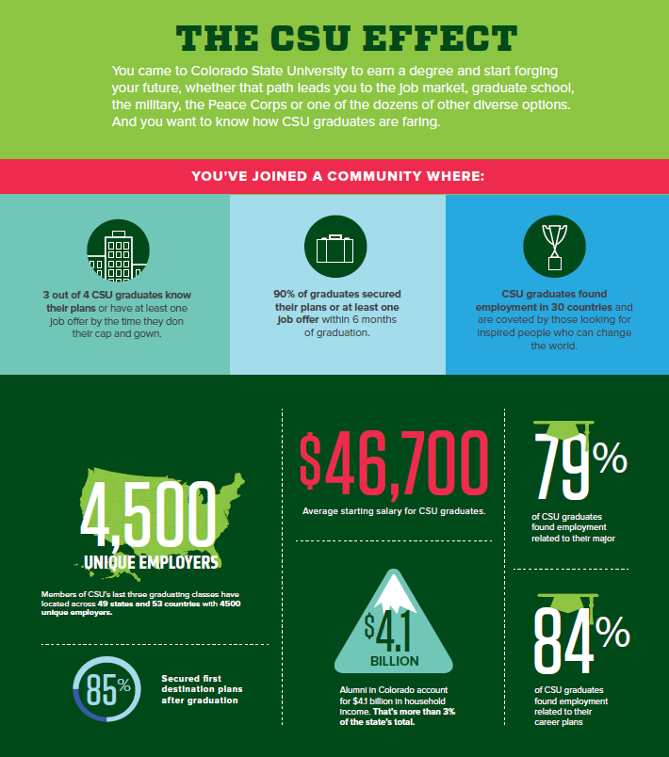

Goal 3: Student Learning Success

- First Year Student Participation - Increased participation at Ram Orientation and First-Year Student Networks
- Ram Orientation attendance increased by 219 students, totaling 4,821 students and 3,879 parents/family members (340 more than the previous year; 56.8% of students bring at least one family member). 25.9% of participants were racially/ethnically diverse, and 23.1% were first generation college students.
- Online Ram Orientation attendance increased by 45 students, totaling 237 new first-year students that participated in Online Orientation. 35% of Online Orientation participants were racially/ethnically diverse, and 27% were first generation college students.
- 282 first-year students participated in First Year Student Network (FYSN), which is an increase of 51 students from the previous year.

- Orientation and Transition Programs - New Student Seminar: Seven sections of the New Student Seminar were offered for 151 first year undeclared students, which is 33 more than the previous year. On a pre and post-assessment, 60.3% students agreed or strongly agreed that they felt confident in identifying appropriate campus resources that would contribute to their transition to CSU on the pre-assessment, compared to 94% (agree or strongly agree) on the post assessment at the end of the semester.
One first-year student from the seminar said, "With the information provided in this class, I have discovered resources I didn't know were accessible to me. Now I can connect with the university and everyone apart of it in a positive way”.

- Collaborative for Student Achievement – Outreach and Support – Early Performance Feedback (EPF): For courses that had 100% section participation in Early Performance Feedback (EPF) at some point between fall 2006 and fall 2016, there was a statistically significant increase in percentages of ABC grades from pre-EPF to post-EPF (76% to 80%)
    - Students who are most likely to rebound with a passing grade after receiving an unsatisfactory EPF feedback rating include first-time full-time students, students who live on-campus, and students with higher academic preparation credentials.

- Collaborative for Student Achievement – Undeclared Advising: The latest National Survey of Student Engagement (NSSE) results indicate that Undeclared Academic Success Coordinators perform at rates similar to department advising and higher than the overall CSU mean in six categories. These categories include academic support options/resources, helping with academic difficulties, discussing career interests, informing about important deadlines, academic rules and policies, and the Advising Construct.

- Ram Orientation First Year Student Retention Rates - The first-to-second year retention rates are higher for students who participate in at least one orientation program, than students who do not participate.
- Of students who attended Ram Orientation and participated in the First-Year Student Network(FYSN) in 2014, 89% returned to the second year at CSU.
- Of students who attended Ram Orientation and participated in the First-Year Mentoring Program in 2015, 92.8% returned to the second year at CSU.

- A 4,564 students took the fall 2016 Taking Stock (TS) Survey; 91% completed the survey, and 87% met with their RA. 93% of students persisted who completed the TS survey and met with their RA persisted to spring semester; 90% persisted who met with their RA about Early Performance Feedback (EPF) ; 92% persisted who had any form of participation with TS/EPF; only 83% persisted who had no participation with in TS/EPF.
- Residence Life began the initial stages of implementing Residential Curriculum at 40% in the fall.
- Since its inception in spring 2009, Party Registration has seen 3,969 CSU student and non-student households register parties, with only 2.4% (95) of these registrations resulting in citations. In a recent survey, 92% of participants agreed that they would recommend the program to friends, up from 89% in FY16.
- First Generation Award: In 11 of the last 13 years, first year recipients of the First Generation Award have shown a first to second year retention rate that is greater than or equal to first year, non-first generation students, and is consistently higher than first generation students without the first generation award. With the 2015 cohort, 100% of First Generation Award recipients retained to the second year, compared to 84.8% of first generation students, which is an increase of 15.2 percentage points for first generation award students.

- Early Performance indicators of “S” for satisfactory or “U” for unsatisfactory were once again collected from participating EPF courses in the 5th week of the semester. Fall 2016 and Spring 2017 EPF outcomes are provided below.
Over the course of the year, the EPF Implementation Team worked with Institutional Research to conduct a comprehensive program evaluation of the last five years of EPF. Key findings of the study revealed the following:
    - For courses that had 100% of sections participating in EPF at some point between fall 2006 and Fall 2016, overall there was a statistically significant increase in %ABCS rates from pre-EPF to post-EPF (76% to 80%), and overall there was a statistically significant decrease in %DFU rates from pre-EPF to post-EPF (20% to 16%).
    - Analysis of the impact of EPF participation at the student level across individual difference variables suggests that students who are particularly likely to positively rebound with a passing grade after receiving unsatisfactory EPF feedback include first-time full-time students, students who live on-campus, and students with higher academic preparation measurables.

- Fall 2016 Taking Stock Survey Highlights

First-year Students
- 4,412 (88%) on and off-campus first-year students completed the survey.
- Of the 4,361 first year students living in the residence halls who completed the survey, 3,566 (82%) met with their RA for a 1:1 conversation.
- FA16 term GPA for first-year on-campus students who completed the survey and met with their RA was 2.98
- FA16 term GPA for first-year on-campus students who did not complete the survey or meet with their RA was 2.37

Transfer Students
- 354 (25%) on and off-campus transfer students completed the survey.
- Of the 199 on-campus transfer students who completed the survey, 162 (81%) met with their RA for a 1:1 conversation.
- FA16 term GPA for transfer on-campus students who completed the survey and met with their RA was 3.00
- FA16 term GPA for transfer on-campus students who did not complete the survey or meet with their RA was 2.26

In the spring, returning first year and transfer students complete the survey during the first 2 weeks of the semester, and new spring-start students complete their survey in the 4th week of the semester. The numbers below are for both returning and new incoming students.
- All Community for Excellence students, with an average index of 112 compared to 115 for CSU, attained a 2.94 cumulative grade point average for the 2016-2017 academic year. This is compared to a 3.08 for CSU undergraduates (excluding C4E students). Given the index and demographics differences, this is positive for the Community for Excellence. Only 6.09% of C4E students were below a 2.0 grade point average and on academic probation. 49.30% of C4E students had a 3.0 grade point average or higher.

- First-year Community for Excellence students, with an average index of 113 compared to 117 for CSU, attained a 2.86 cumulative grade point average. First-year CSU students (excluding C4E) attained a 3.01 cumulative grade point average. Given the index and demographic differences between these groups, this is positive for the Community for Excellence. 12% of C4E first-year students had below a 2.0 grade point average.

- This year Student Success chaired a university wide committee dedicated to exploring and enhancing the experience of Student of Concern at CSU. Students of Concern are incoming first year students who, through the Admissions Holistic Review Process, have a need for further support for their success at CSU. Specifically this year the committee expanded the admisions flags from 8 to 23 to further specify the needs of students and provide a foundation for future intervention paths. Looking into the next year, the Students of Concern Committee will collaborative work with partners across campus to create intervention strategies for these incoming students and support their success.

- Student Legal Services advised and steered over 1,000 students in solving their legal challenges using a guided self-help approach, with multiple follow up appointments, resulting in learning that students will apply life-long.

- Student Legal Service’s impact on student learning and retention and preparation for living in civil society is reflected in client satisfaction survey results. The following percentage of survey respondents answered that they agreed with the following statements and learning outcomes.

The staff was polite and helpful during the screening process. | 97%
Prior to coming to Student Legal Services, my legal issue was causing me stress. | 89%
I was satisfied with the legal service provided by my attorney. | 96%
I was more prepared and better able to resolve my legal issue. | 94%
I better understand my legal rights and responsibilities. | 96%
I am more inclined to anticipate consequences and avoid unnecessary problems in the future. | 96%
I feel more confident in my ability to handle future legal concerns that do occur. | 94%
I am more motivated to carefully read legal documents before signing them. | 92%
I am better able to negotiate a fair compromise in a dispute. | 90%
I will recommend SLS to other students. | 96%

- CSU Health Network - Alcohol and Other Drug – Prevention Services
- AlcoholEdu Program:
- 6,590 students completed AlcoholEdu Part 1; required for incoming undergraduates under the age of 23 (few exceptions).
- Students reported that the course helped them establish a plan for responsible decisions around alcohol (88%), prepared them to identify and/or help someone who has alcohol poisoning (90%), changed their drinking behavior (46%) and changed perceptions of others’ drinking-related behaviors (61%).
- Students also reported an average increase of 20% from pre to post course knowledge of risk reduction, physiological effects of drinking, general alcohol knowledge, understanding the influence of alcohol and factors influencing drinking behavior.
- After completing the course, 87% of students reported the course prepared them to make responsible decisions about drinking.
- Students reported the course prepared them to prevent an alcohol overdose (86%), help someone who may have alcohol poisoning (88%), helped them establish a plan ahead of time to make responsible decisions about drinking (87%) and changed their perceptions of others’ drinking behavior (60%).
- Among the 52% (315 students) of high-risk drinkers who saw “no need to change the way they drink” before taking Alcohol Edu, 55% (173 students) indicated readiness to change after completing the course.
- Haven: Understanding Sexual Assault Prevention Program:
- 9,054 students completed Haven: Understanding Sexual Assault Part 1; required for all incoming students (few exceptions).
- Students reported high levels of knowledge before taking the course, including the definition of stalking (94%), alcohol-facilitated sexual assault (94%) and understanding sexual consent (97%).
- Gains were observed in knowledge of the root causes of sexual assault (73% to 79%), characteristics of sexual assault perpetrators (87% to 94%), alcohol as the most common date rape drug (74% to 91%), and strategies for supporting sexual assault survivors (87% to 95%), bystander intervention strategies (91% to 95%), and campus disciplinary resources (93% to 97%). Knowledge of sexual assault prevalence had the lowest percentage of correct responses across all areas at pre post (53%, 60%), but slightly greater than the national average (50%, 54%).
- Students reported that the course:
- Helped them identify characteristics of healthy and unhealthy relationships (84%).
- Taught them where to find resources for sexual assault and abusive relationships at CSU (84%).
- Made them more confident in their ability to intervene when observing concerning behavior (82%).
- Provided them with skills to better support someone who has experienced sexual assault (84%).
- Increased their understanding of school policies related to issues covered in the course (86%).
- Provided them with information about sexual consent that they plan to use if they choose to be sexually active (85%).

- The Ramskeller partnered with Fermentation Science and Technology to develop a new craft brewery operation in the Lory Student Center.

- SLiCE is home to Rams Against Hunger, which provides emergency food relief to students who have no idea where their next meal is coming from or how to pay for it. During the fall and spring semesters, Rams Against Hunger provided a total of 212 students with meals via their RamCard. Each student received 75 meals on their RamCard (or a prorated amount based on when they applied for the program). Throughout FY17, the Rams Against Hunger fund received significant support from CSU faculty, staff, students, alumni, and numerous community members who contributed a total of $52,177.60 to the program. CSU’s Annual Day of Giving in April featured Rams Against Hunger with hundreds of donors contributing $16,616 to the fund.

- The Student Leadership, Involvement and Community Engagement Office registered 476 student organizations, an increase from the previous academic year.

- Campus Recreation professional staff performed 386 evaluations of student employees during FY17 which covered topics such as communication, conflict management, leadership, interpersonal skills, job knowledge, and more.

- Campus Recreation supported academic internships for 12 students in the areas of fitness, marketing, injury care, intramural sports, and assessment. In addition, two student athlete internships were supervised during the summer.
- Campus Recreation Communications hosted professional headshots for student staff. The student Photography Assistants, Al Alothman and Chiara Garland, were able to photograph more than 40 student staff members and provide a high-quality headshot for their future professional growth and development.

- Due to a new certification achieved by Nick Pfeifer, Aquatics Coordinator, Campus Recreation was able to begin hosting American Red Cross Lifeguard Instructor Training courses on campus. The ability to hold these classes improved the speed with which current Lifeguards could become certified as Lifeguard Instructors and also reduced the cost and other barriers often in place for student employees to take that level of certification course. The first class was held during Spring 2017 and six student employees earned their Lifeguard Instructor certification, making them eligible to teach American Red Cross classes for Colorado State University students.
- Ryan MacTaggart, Special Projects Intern, assisted Ben Burnham, Assistant Director of Facilities and Aquatics in the creation of the Recreation Supervisor Development Program. At the weekly Recreation Supervisor meetings, the student staff participated in sessions designed to provide professional and personal advancement for the Recreation Supervisors in regards to their position within the Student Recreation Center and in their transitions after graduation. Topics included communicating personal and team purpose, how to best operate as Recreation Supervisor, the relevance of the skills and knowledge of the experience after graduation, aligning a personal purpose statement with that of the team/department, building/maintaining accountability on a team, creating trust with colleagues and management, resume and interview information, organizational politics, giving and taking feedback, learning from setbacks, and participating in employee evaluations.

- CSU Health Network - Mental Health – Prevention Services
- FY17 Mental Health/Resiliency and Well-Being Outreach Contacts Total: 3929, 6% increase from FY16.
- You@CSU:
- The YOU@CSU portal has been developed for students to explore their strengths and areas for growth across three domains: SUCCEED – Academics/Career, THRIVE – Physical/Mental Health, and MATTER Purpose/Community/Social. The portal serves up relevant educational information and campus resources to support a student’s success at CSU. The content becomes personalized as students’ complete brief assessments, complete a profile or search for something specific.
- YOU@CSU had consistent use since launching in February 2016. Strategic promotion and communication about YOU@CSU was integrated into Ram Orientation, Ram Welcome, Residential Curriculum Program, as well as broad campus promotion of the new tool. Coordinated communications with the President’s office and mentions during Convocation helped to drive traffic to the site. Ram Orientation Leaders, Transfer Transition Mentors and Ram Welcome Leaders were trained on the YOU@CSU tool as a way to help connect students to support and campus resources.
- Analytics July 1, 2016 – June 30, 2017 show:
- 17,200 visits
- 11,398 users (34% repeat users)
- 5,742 students have registered (233 staff/faculty)
- Average time on site is 5.25 minutes
- 2,747 searches were conducted using the site
- Students have completed over 2800 Reality Checks (self-assessments) across all three domains, which enables the site to customize content based on the users’ needs and interests.
- Key findings from two surveys (Fall 2016 257 respondents and Spring 2017 247 respondents) showed:
- 74% reported that YOU@CSU helped to improve their ability to manage stress.
- 22% reported searching/learning about campus resources as the function used most when logging into YOU@CSU. Second was Reality Check assessments at 27%.
- 39% visited or used a campus resource because of their interaction with YOU@CSU.
- Notice and Respond, a campus-wide suicide prevention curriculum:
- Notice and Respond training continued with 1487 participants, a 49% increase from FY16. 400 more students trained than the previous year.
- There were 48 sessions: 7 staff sessions, 91 participants; 36 student sessions, 1303 participants; 5 faculty sessions, 93 participants.
- 90% of 690 survey respondents agreed or strongly agreed that they had gains in awareness of the signs of distress, an increased understanding of campus resources and felt more confident and empowered to assist someone in distress.

- CSU Health Network - Resiliency and Well-Being – Prevention Services
- Resiliency and Well-Being – Staff assisted with the new Health and Medical Center Still Point Reflection space design, furniture selection and relaxation pod and supply purchasing. Space guidelines were created. A student assessment of stress reduction technology was conducted and results were used to purchase technology for rollout in FY18.
- Growth Mindset Training:
- A full day and evening Growth Mindset campus training provided resilience and persistence tools for faculty, staff and student leaders to use in their work with students and build the foundation for growth mindset initiatives to come. 366 staff and faculty from 170 different departments and 130 students from 46 departments/groups registered.
- Pre post training results showed positive gains:
- Student Leaders – Pre training 35% vs 88% post reported knowing how to promote a growth mindset. Pre training 27% and 69% post reported knowing how to promote a belonging mindset.
- Facility and Staff – Pre training 18% vs 69% post reported that they knew how to promote growth mindset. Pre training 29% vs 62% post knew how to support a belonging mindset.
- The training was the catalyst to move forward the development of the growth mind set intervention for new students and continuation of faculty training planned.

- CSU Health Network - CREWS Peer Education – Prevention Services
- Rams Take Care, Rams Take Action:
- This Ram Orientation initiative included alcohol norming and bystander education messaging. Orientation Leaders were trained in program content, motivational interviewing, bystander intervention and skills to assist with implementation.
- Pre post evaluation conducted by the Applied Psychology Program indicated positive program indicators. Students were asked four questions that assessed the level of knowledge and helping skills participants gained from the program. The results revealed a significant increase (p < .05) in knowledge about helping skills. Students answered three questions about benefits to helping others in an alcohol-related emergency and four questions about barriers to helping others in an alcohol-related emergency. The survey results showed a significant increase (p < .05) in perceived benefits to helping and a significant decrease (p < .05) in perceived barriers to helping.
- Apartment Life offered Spanish, English and Arabic classes weekly to help residents develop skills in speaking and writing in a second language.
- The CSU Mountain Campus continues to host Transfer and First Year Mountain Experience Programs and the Poudre School District Environmental Education (Eco-Week) Programs (10 Weeks).

- Residence Life RAs and A/RDs made outreach to 1,124 students with academic difficulties during the Fall 2016 Early Performance Feedback program; 371 had meetings with their RA. During the Spring 2017 Early Performance Feedback program RAs and A/RDs made outreach to 829 students with academic difficulties; 263 had meetings with their RA.

- Probation rates declined for undeclared students after Fall 2016, as the rate for declared students rose. First year undeclared students on probation decreased 2% after the first semester. Declared student probation rates increased 2.1% after the first semester and over 1% for the end of the first year. Advisors for undeclared students have worked hard to reach out to all of their students and provide resources and support.
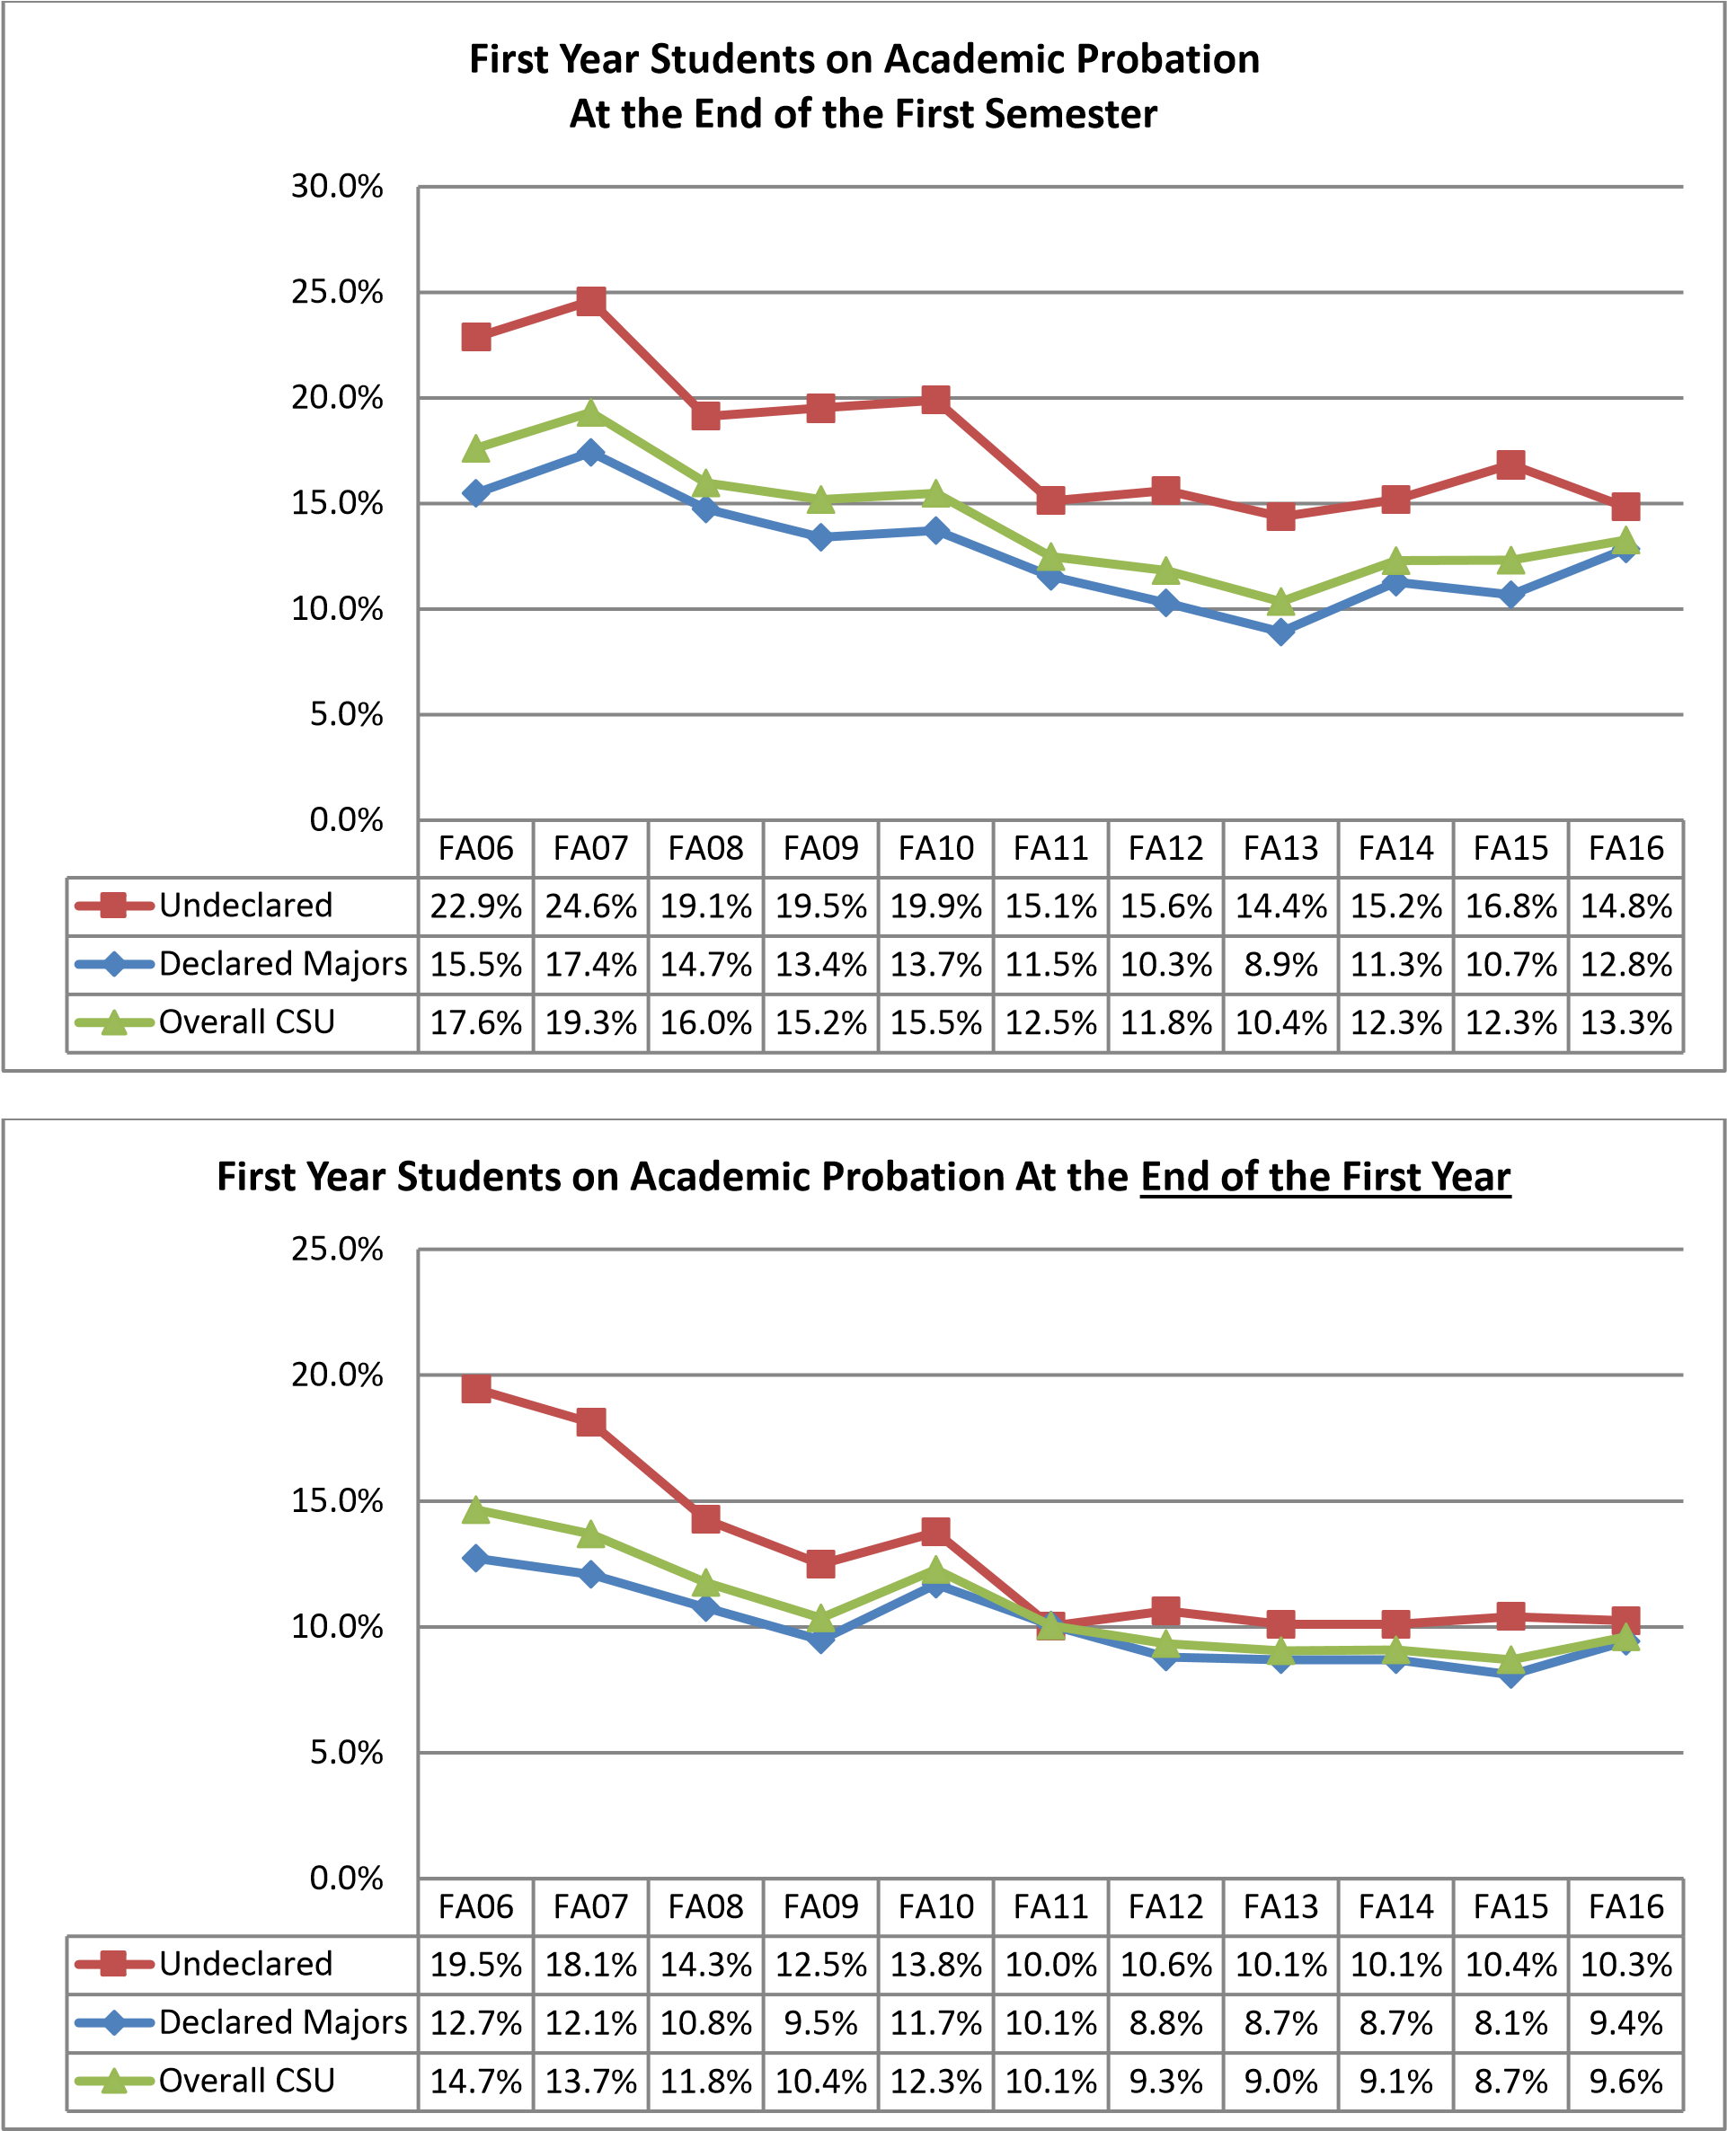
- Parent and Family Programs composed, edited and published a monthly electronic newsletter sent to over 18,000 parents and families, and also posted health and safety messages on the Parent & Family website (and sent to families as needed).
  - Provided multiple vehicles for communicating information about substance use/abuse and mental/physical health issues, and safety to parents and families, alternating each month’s newsletter between public safety and health articles to share information with families.
  - Posted all safety updates and relevant information on Facebook page, including links to information about SafeWalk, bike safety, and CSU Health Network tips.
  - Partnered with CSU Health Network to provide all parents and family members of incoming students with access to the Parent and Family Handbook for Talking with College Students about Alcohol.
- Tracking the fraternity and sorority GPA over time indicates that fraternity and sorority average GPAs continue to outpace unaffiliated peers.
  - Fall 2016: the all f/s GPA was a 2.95 compared to an all undergraduate GPA of 2.90 (all sorority GPA is 3.10 compared with a 3.0 all women’s, all fraternity GPA is a 2.8 compared with a 2.8 all men’s)
  - Spring 2017: all f/s GPA was a 3.06 compared with an all undergraduate GPA of 2.95 (all sorority GPA is 3.09 compared with a 3.06 all women’s, all fraternity GPA was a 2.85 compared with a 2.84 all men’s)

Goal 4: Research and Discovery

- The 2017 MURALS program has experienced a 340% increase in student participation since its inception.
DEMOGRAPHICS
Year | # of students | # of presentations
2017 | 75 | 64
2016 | 42 | 39
2015 | 17 | 15
Faculty Judges – 39

- The Aspen Grille worked with the Health and Human Sciences department in a food study to determine effectiveness of techniques used to increase nutrient intake of children in a restaurant setting.

- Apartment Life hosted a program for student researchers to share the research they are working on to learn from each other and receive ideas or feedback from each other.
- Housing and Dining Conference and Event Services assisted with registration and logistical planning for many research focused events such as Graybill (CSU-Department of Statistics) and the Bat Symposium (CSU-Department of Microbiology, Immunology and Pathology).

- As all data informs decisions with student success work at CSU. The Student Success area works hard to use institutional data to inform all decisions. Data collection is also critical for the future of initiatives and projects. We will continue to use data in meaningful ways moving forward.

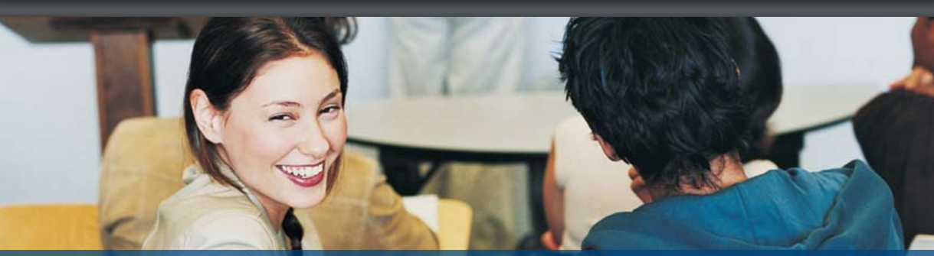

Goal 5: Engagement

- The Housing and Dining departments of Residential Dining Services, Communication & Sustainability, and HDS Operations Management once again played a part in helping the University achieve its second Platinum S.T.A.R.S. award in two years. Programs like our organic whole fruit and composting practices helped drive those successes.
- The Ramskeller worked with RamEvents and FOCOMA to co-host the FOCOMX kickoff show. This program showcases over 200 local bands in 20 venues around Fort Collins every April.

- Cam’s Lobby Shop worked with Parking and Transportation Services on a coupon that rewarded and encouraged the campus community to take advantage of riding the bus onto campus.
- For the 16/17 year, Event Services had 4,769 reservations, which resulted in about 13,675 event bookings.

- Using funds provided by a generous donor, the LSC Arts Program was able to add two pieces of art made by local artists to the Experiencing Colorado exhibit on Level 100 of the Lory Student Center.

- RamEvents collaborated with student organizations, offices, and departments, which enhanced programming by having multiple perspectives in the planning process and resulted in significant learning experiences for the staff and volunteers, as well as participants. Approximately 25,000 participants were served by 71 RamEvents programs this year.

- SLiCE hosted the first-ever Mobile Food Pantry on campus for three dates as a trial project. The number of students, faculty, and campus community that benefitted from the mobile food pantry resulted in 900 individuals in attendance. There were 75 total volunteers from these three dates resulting in 150 hours of total service and leadership. In all, 25,000 pounds of food was distributed as a result of these events.

- SLiCE hosted the 30th annual Cans Around the Oval. This single-day food drive, benefitting the Food Bank for Larimer County, brought in $57,714 and 41,670 pounds of non-perishable food items.

- Campus Recreation Communications designed, printed, and distributed marketing materials for over 130 department events, activities and programs throughout FY17. From website visitors, social media interactions, the Rec’ing Ram newsletter, department communications had nearly 174,000 digital impressions. The website alone had over 45,000 unique website visitors, and the YouTube account had over 56,000 views.

- The Employee Appreciation Committee organized the first annual Homecoming Student Staff Alumni Reception in October 2016, which brought approximately 45 former student employees back to the Student Recreation Center. The primary goal of this event was to reconnect former employees to the department in hopes of fostering stronger relationships with alumni and potential supporters of Campus Recreation programming and services.

- Intramural Sports continued the strong relationship built with Colorado State Athletics and was able to gain more time in the Indoor Practice Facility which allowed for a significant expansion of the 4v4 Indoor Flag Football League. Total participation was up 23% with nearly 100 more unique participants able to play in the Spring 2017 league.

- Intramural Sports were nationally recognized on two separate occasions and featured in Campus Rec Magazine in February and March 2017; articles highlighted the programs innovative marketing strategies and the diverse, non-traditional programming opportunities offered.

- CSU Health Network leadership developed a supportive working relationship with building partners, UCHealth, Associates in Family Medicine, Columbine Health Systems, Kendall Reagan Nutrition Center, College of Health and Human Sciences, and CSU Facilities Management.

- CSU Health Network HEPS External Partners included Alliance for Suicide Prevention, BACCHUS Network, City of Fort Collins, Cactus Advertising – Grit Digital Health, Columbine Health, Fort Collins Interfaith Council, John Hunter Hauck Foundation, Larimer County Department of Health and Environment, Larimer County Mental Health and Substance Abuse Committee, Poudre School District, Regional Mindfulness Network, Team Wellness Fort Collins, Tobacco Free Larimer County, Summitstone Mental Health, UC Health, Regional Universities.

- The annual NACUFS Customer Satisfaction Survey showed Residential Dining Services ranking above the national average in satisfaction with the Dining Environment, and above the industry average for environmental stewardship. We saw a slight decline in overall satisfaction, but expect that implementation of the feedback received through the NACUFS Professional Practices Peer Review, our new Text and Tell program, and other venues will assist us in making appropriate changes to increase our ranking during the next survey period.

- State of What’s Next Communication Campaign for Student Success at CSU – Student Success collaborated with University Relations in creating a brand and communication campaign for student success at CSU which lauched with a event on the Plaza annoucing the brand. Branded items include posters and flyers for communcation, pens, and stickers. Campaign also used May’s issue of the CSU magazine to share about the first 10 year effort of student success at CSU.

- In collaboration with the City of Fort Collins and Off-Campus Life, the Fall Clean Up event matched over 1,800 CSU students and staff (up 38% from FY16) with 287 neighborhood projects (up 19% from FY16). Additionally, over 4,500 bags of leaves were collected (up 11% from FY16). Survey results showed the following:
  - 97% of respondents agreed or strongly agreed that assisting in Fall Clean Up helped them feel more a part of the Fort Collins community.
  - 90% agreed or strongly agreed that by assisting in Fall Clean Up, they were more aware of what it takes a person to maintain a yard.
  - Since the program’s inception, over 24,000 bags of leaves have been collected, over 10,000 volunteers have participated, and 1,733 projects have been completed (see graphic below).
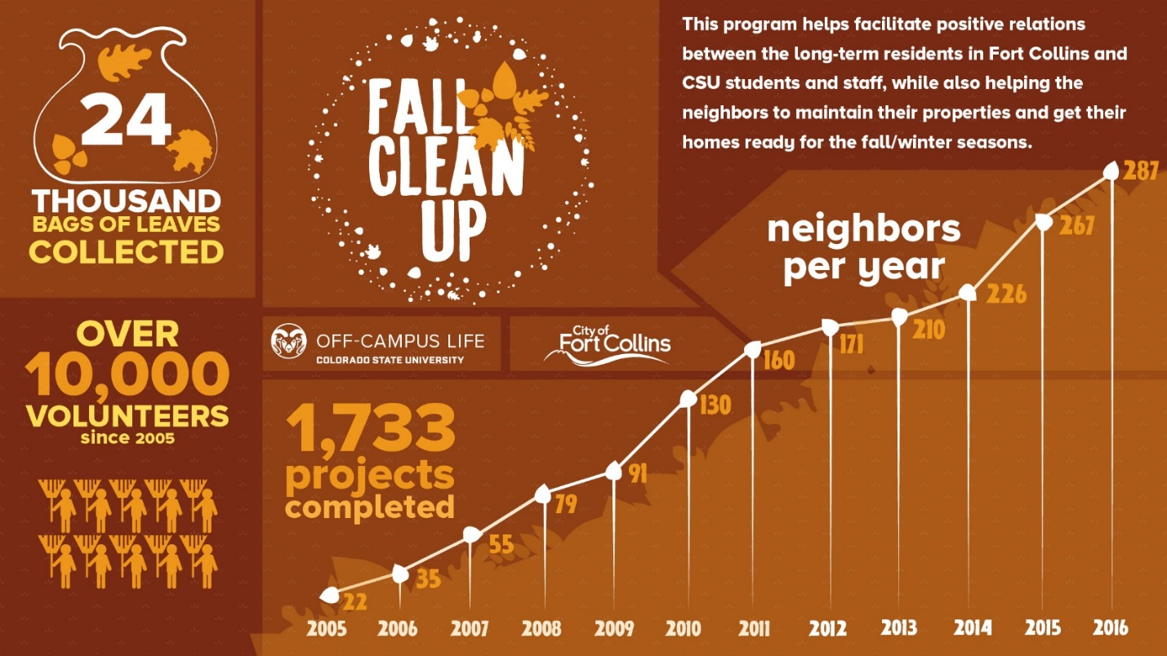

- Off-Campus Life continued the Get the Scoop program taking place on August 6th and 7th, 2016. Staff collaborated with Divine Ice Cream, FCPS, and City of Fort Collins Code Enforcement to drive through specific neighborhoods, hand out free ice cream, and distribute Art of Neighboring brochures and information about meeting their neighbors. Contact was made with a total of 46 long-term residents, 204 student renters, and 37 non-student renters. Participants surveyed stated the following:
  - 99% believed the event would have a positive impact on their neighborhood.
  - 99% believed the University and City should continue to encourage residents to meet one another through this event.

- In collaboration with the City of Fort Collins and Off-Campus Life, the fall 2016 Community Welcome event connected over 200 volunteers with over 1,200 neighbors, all of which received educational material and “The Art of Neighboring” brochure. An assessment of this program indicated the following:
- 92% of respondents agreed that staff/students/police should educate students about local codes and ordinances.
  - 80% of volunteers and 90% of neighbors agreed that the Community Welcome efforts will have a positive impact in the neighborhoods.

- Off-Campus Life’s involvement in the spring 2017 CSUnity project connected student volunteers with 220 elderly or disabled City residents (up 10% from spring 2014) as part of this spring outreach program. Survey results from the CSUnity Neighbor Evaluations were as follows:
- 99% strongly agreed/agreed that they were satisfied with the service they received during CSUnity.
- 94% strongly agreed/agreed that as a result of CSUnity they feel more connected to CSU students.
- 100% strongly agreed/agreed that due to CSUnity they have a greater appreciation of students as neighbors in their community.
  - 93% strongly agreed/agreed that without the program they would be unable to prepare their homes for the spring/summer season.

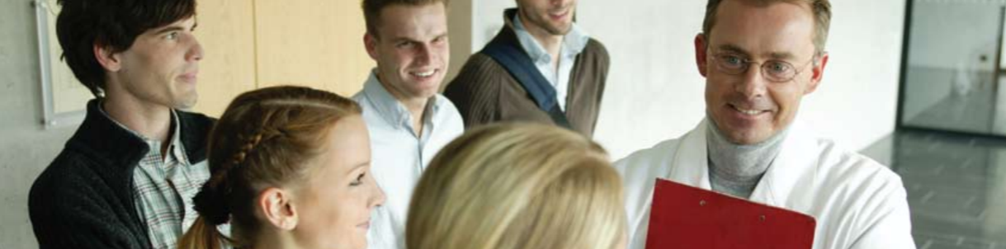

Goal 6: Public Interaction / Strategic Partnerships

- The Career Center’s Colorado Industry Tour initiative led eight career exploration and connection days for 20 - 40 students per trip; allowing them to see the inner workings of three diverse companies on each visit and connect with Alumni.

- Fraternity and sorority members contributed a total of 68,437 hours of community service and raised $127,298.61 for philanthropic causes.

- The CSU Bookstore partnered with Athletics to operate a new on-campus stadium retail store.

- The CSU Bookstore supplied materials and merchandise to three Semester at Sea voyages.

- Residential Dining Services, in collaboration with the Office of the President and the Rohr Chabad Jewish Center of Northern Colorado, celebrated the grand opening of the Kosher Bistro in October of 2016. All customers are welcome to eat at the venue, where our dedicated Mashgiach provides great food and opportunities to our students for learning.
The venue has proved to be very popular and provided over 4,000 meals to students during the Fall Semester and 3,600 in the Spring Semester.

- Housing and Dining reached a milestone of one million pounds of food waste diverted from the landfill through our composting and waste-to-energy initiatives was achieved in 2016. The public access composting was implemented in every dining center, and students were able to compost their post-consumer products. During 2016, the Earth Flow Composter diverted 401,326 pounds of material from the landfill.

- Residential Dining Services contributed around 70,000 pounds of food to the Larimer Food Bank.

- Lory Dining Services began working with leadership from the department of Soil and Crop Sciences as well as CSU Facilities on a pilot program for composting food waste in kitchen areas.

- Lory Dining Services worked with the Spirit Crossing Clubhouse on opportunities for transitional employment for adults with mental health disorders as they pursue personal recovery and wellness goals.

- RamEvents hosted The Head and the Heart for RamFest 2016 and 5,771 people attended the show.

- This was the first year that SLiCE organized Homelessness Awareness and Action Month (HAAM). HAAM included a total of 16 events during the month of November including social justice conversations, street outreach, documentaries, community meals, and guest speakers. A total of 321 participants attended the various events.

- CSUHN Student Health Insurance department partnered with Larimer County Connect to help students find and enroll in the right insurance program for them.
- CSUHN Leadership worked closely with building partners in establishing shared Radiology services. Developed an agreement that utilizes CSU staff for UCHealth Radiology as well as a user agreement for the provision of their radiology services to us.
- A team of providers from Medical Services, led by Dr. Bruce Smith, collaborated with the Northern Colorado Aids Project (NCAP) to provide pre-exposure prophylaxis to CSU students. Commonly known as PrEP, pre-exposure prophylaxis is a way for people who do not have HIV but who are at substantial risk of acquiring it to prevent HIV infection by taking a pill every day. The collaboration with NCAP provided resources for students to obtain financial assistance and education through their office, and a referral source to the clinic for the prescribing of medication.
- Apartment Life continued housing partnerships this year, including Office of International Programs, housing 54 Chinese Partners, 22 Vietnamese Partners, 10 Research Experience for Undergraduates (REU) Students, and more than 60 INTO CSU Academic English Students across our system.

- IPASS Grant through Gates Foundation – Integrated Planning and Advising for Student Success (IPASS) is a multi-year grant supporting the use of technology in the advising process to promote student succes. Much of the ongoing grant work happens through student success including:
  - Monthly calls are completed providing updates to the grant work back to our grant Director
  - Coordination of committee meetings
  - End of Year reports including data and ongoing efforts towards critical goals and KPIs for the grant
  - Budget including tracking of salaries and expenditures

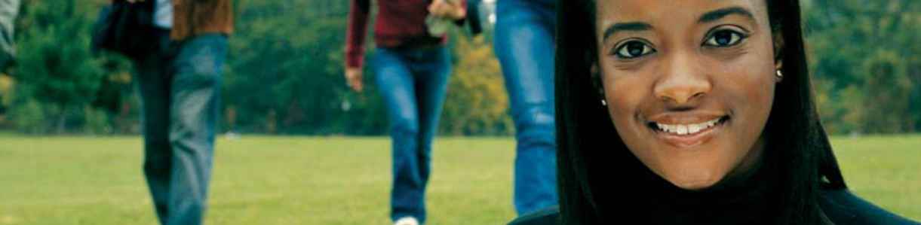

Goal 7: Excellence in Hiring, Professional Development, Employee Engagement

- Campus Activities hired two new professional staff members; both are people of color and have added diverse perspectives to the Campus Activities team.

- Throughout Fall 2016 and Spring 2017, Campus Recreation employed an average of 300 students. The following demographic breakdown is an average over both semesters:
Ethnicity | Sex | Class
- Native American 2 (1%)  - Asian 6 (2%)  - Black 10 (3%)  - Hawaiian/Pacific Islander 2 (0%)  - Hispanic/Latino 23 (8%)  - Multiracial 10 (3%)  - White 231 (77%)  - Not Disclosed 17 (6%) | - Female 163 (54%)  - Male 138 (46%)  - Blank 0.2 (0%) | - First year 32 (11%)  - Sophomore 78 (26%)  - Junior 86 (29%)  - Senior 92 (31%)  - Masters 4 (1%)  - PhD 5 (2%)  - Professional Level Two 1 (0%)

- CSU Health Network Dental Services were again restructured, with a change from having several part-time contract dentists to hiring a full-time dentist as supervisor of the clinic.

- CSU Health Network Medical Services worked with Human Resources to create an Administrative Professional hourly position, in order to hire relief physicians, nurse practitioners, and physician assistants. This has been cost-effective and very helpful to correct staffing at various times of the year.

- CSU Health Network Counseling Services initiated a plan that allowed licensed Academic Year staff to be hired as Administrative Professionals, rather than non-student hourly staff. With the addition of these salaried, benefitted, exempt positions, employee engagement increased the stability/desirability of the Academic Year program. With greater longevity in the position, staff were more fully integrated in the Health Network and the campus community, and increased their knowledge about resources and made more effective referrals.

- The new CSU Health Network building allowed Counseling Services to consult more efficiently with the Psychiatry Department since we now have two psychiatrists in the Counselling Services area.

- Collaborative for Student Achievement – Business Operations and Support Services collaborated with the Training and Organizational Development office and formed a Customer Service Committee based on the Disney Institute training. Fourteen Student Achievement staff members met, developed a customer service philosophy, and created a proposal for how to handle customer service and the support services in our new location.

- Housing and Dining Staff Training piloted and implemented a new cohort-based Supervisory Leadership Series for current and aspiring supervisors.

- In the fall of 2016, Residential Dining Services took a new stance on employee meals. Due to work related restrictions and desire to serve the best food for our customers, employee meals are offered in their work locations rather than as a daily meal deduction from employee’s paychecks.

- The Employee Wellness Program was continued and expanded to multiple other areas of Housing and Dining Services during 2017. The Program includes wellness challenges, nutrition classes, fitness and yoga classes, and much more. The program is designed to promote healthy eating, mindfulness, and physical activity. During the summer of 2017, 108 employees from Residential Dining and 31 Employees from other departments within Housing and Dining participated in the Summer Wellness challenge. Participants could choose up to 4 of 8 ‘challenges’ including physical activity, water intake, sleep time, vegetable intake, etc.

- Apartment Life & Residence Life redesigned and implemented new staff on-boarding processes for all staff inclusive of full-time, graduate, undergraduate student and even mid-year student staff hires.

- Academic Success Coordinator (ASC) Tiered Model – currently a working group is gathering to write, engage and apply competencies for ASCs at CSU to contribute to the greater knowledge of an ASC position and to develop a process of rewarding/promoting the exemplary work of ASCs. A goal of the process is to also provide additional financial compensation to ASC positions.

- ASC Leads – further development is needed to support the ASC network efforts on a daily basis and create a strategic and effective communication and delivery of university wide student success initiatives for ASC work. A position description has been developed stating college level coordination of ASCs, outreach and campaign support for college level efforts, and using data and research to continue to inform college level work as main responsibilities. Positions are proposed to dually report to Student Success Manager and Associate Deans within each college.

- The Career Center’s new coordinated student career staff model has proved effective in scaling service delivery. This coordinated approach by all four teams in the Career Center hired nearly 40 students into a diverse array of roles such as student outreach ambassador, employer relations specialist, design intern, and peer advisor.

- The Office of Fraternity & Sorority Life completed a reorganization, leading to a new staffing model and the creation of an Assistant Director position. The office is fully staffed utilizing this new model.

- The Women and Gender Advocacy Office hired two new victim advocates, and an assistant director for prevention education this past year.

- Thirteen graduate students in the Student Affairs in Higher Education program serve as Chapter Graduate Advisors (CGA) for thirteen chapters in the fraternity/sorority community. The CGA program is unique, providing direct support to fraternities and sororities and creating opportunities for graduate students to gain advising experience and work in the fraternity and sorority functional area.

- The Student Resolution Center successfully conducted hiring processes for eight SRC staff positions.

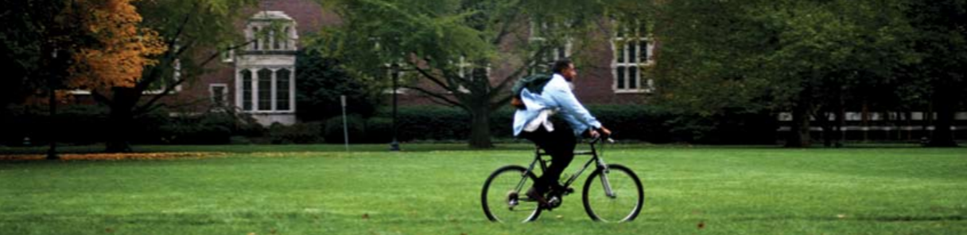

Goal 8: Diversity, Equity and Campus Climate

- Women and Gender Advocacy Center experienced an increase of survivors of approximately 129% from last year; and the number of cases are more than 8 times higher than they were in 2010-2011, the year prior to receiving the student fee. Although it is important to track this data over a multiple year period, the staff know based upon their in-take process that students were more aware of the WGAC services based upon the marketing efforts.
- Adelante Con Nuestros Padres (going forward with our parents): Adelante was a new program implemented in August 2015. Over 300 incoming freshman with primarily Spanish speaking parents received an invitation to attend the Spanish orientation in fall 2016. The goal was to provide resources in Spanish to these students, parents and families. A consistent struggle Latinx students face is they are often the first in their families to pursue a higher education and their parents/guardians do not understand the skill set necessary to be a successful college student. Adelante was successful in educating parents and families and helping them to become the best support system for their children.
- The “Being Black And . . .” series allowed space for students to explore intersectionality with black being one of the interesting identities. In the 4-part discussion, students spoke amongst faculty and staff about their multiple identities and they show up in different spaces. There was much discussion surrounding while they may have one identity in common (being black), other identities held influences their why, what, who, when, where and how.

- As part of an ongoing commitment to campus inclusivity, Ram’s Horn at the Academic Village Commons converted its upstairs restrooms into two Gender Neutral Restrooms.

- Key Communities/University Learning Communities: Inclusive Community - Highlights from the 2016-2017 Learning Community Student Experience Survey from Key Communities:
“I feel that my Learning Community is welcoming of people of my background and experience.” 88% of Learning Community respondents agreed/strongly agreed.
“I feel like I belong in my Learning Community.” 76% of Learning Community respondents agreed/strongly agreed.
- The CSU Health Network annual winter all-staff meeting again focused on diversity and inclusion, with the theme of “Re-envisioning Community.” Mary Ontiveros was the keynote speaker and trainers from the Vice President for Diversity Office led workshops for staff.

- Most of the staff in the CSU Health Network Hartshorn Building participated in “Safe Zone” training during the summer and fall of 2016, provided by the PRIDE Resource Center.

- The CSU Health Network Data Collection Cycle and Distribution is listed below:
- NASPA Mental Health Survey was implemented Spring 2017. Benchmarking report being updated.
- National College Health Assessment (NCHA) implemented with Athletes Fall 2016. Benchmarking report complete; sharing with Athletics September 2017.

- Asian, Hawaiian/Pacific Islander, and Native American students used Career Center services at rates proportional to their campus representation. Black/African-American, Latinx, International, and Multiracial students used the CS services at rates higher than their proportions on campus. Gender representation in terms of service usage was close to representations for men and women (trans* student data were not collected).

- 40th Anniversary El Centro & B/AACC - In recognition of the contributions alumni, students, former and current staff/faculty have made people across several decades returned to campus, some for the first time since graduation. The reunion festivities consisted of a joint dinner with El Centro and a 10-piece ad led by Valerie “Peaches” Embry. Saturday before kickoff alumni enjoyed a tailgate and then a thunderous homecoming win. Sunday, current students were engaged in conversation with alumni as they shared their stories when they were students to what they are doing now. The weekend ended paying homage to Abyssinian Christian Church as they were and still are instrumental helping students find a sense of community. The church was founded via the office.
- http://source.colostate.edu/40th-anniversary-brings-baacc-el-centro-alums-together/
- Event Services trained student staff how to provide inclusive customer service, including language barriers, and cultural and belief differences.

- Campus Step Up: A Social Justice Retreat sponsored by SLiCE had 61 student participants who completed a pre- and post- program assessment with 17 shared Likert scale (1-5) questions about participants’ comfort in engaging with categories of identity and their level of understanding around social justice concepts. Results highlights included: 100 percent of respondents selected Strongly Agree or Agree to their experiences to create a safe environment for all people within their community, 100 percent of respondents selected Strongly Agree or Agree to recommending this retreat to other CSU students, and 96 percent of individuals selected Strongly Agree or Agree on feeling better equipped to understand the perspectives of those who are different from them.

- Campus Recreation Communications planned and executed the implementation of the Inclusion Infusion poster series in collaboration with the Inclusivity Committee. The program has two layers of education. First, professional staff research content for an inclusion-related topic. Second, the content is delivered to the student staff via a poster designed by Communications. Topics covered in the fall include an introduction to identity, definition of an ally, and how to be an advocate. The series will continue through spring semester.

- The Campus Recreation Inclusivity Committee created a survey related to adaptive recreation. The goal was to have a better understanding of what types of programs, facilities, equipment, and services are of most interest to students who identify as having a disability. The survey was distributed by campus partners in the Resources for Disabled Students office via their listserve, as well as posted online on the Campus Recreation website. There were 143 survey respondents and the committee discussed the results of the survey:
  - Most respondents were undergraduate (86%) women (71%). Of the undergraduates, 27% were first-year students, 17% were sophomores, 29% were juniors, 20% were seniors, and 7% were fifth-year students. The most common disabilities identified by respondents were learning disabilities (33%), mental health conditions (30%), and chronic health conditions (11%). The most comment responses to use of the Recreation Center were one to three times a month (27%), one to three times a week (20%), once a semester (19%), and never (19%).
  - When analyzing disability and Recreation Center usage, it was noted that only 30% of people with learning disabilities use the facility on a weekly basis, 50% of people with a physical disability have never used the facility, 100% of people with a wheelchair have never used the facility, and a quarter of people with a mental health condition have never used the facility.
  - The top reasons for not using the facility were being unaware of the programs/services (n = 14) and not feeling comfortable exercising in front of others (n = 7).
  - The new programs and services identified by the respondents as most appealing were horseback riding (n = 38), personal training (n = 36), access/use of sauna (n = 28), archery (n = 23), adaptive yoga (n = 23), and accessible hiking/backpacking (n = 18).

- Campus Recreation Communications planned, coordinated, brainstormed, and created the New to the Rec Guidebook in response to the departmental inclusivity audits’ identified need. The Guidebook helps to orientate new students and participants to the department of Campus Recreation in order to reduce the barriers that may be present in traditional gym/recreation environments. The Guidebook covers topics such as gym lingo, navigating the Student Recreation Center, where participants can find support, and more. In addition to the printed Guidebook, a video is currently being created to provide a second avenue to the information to maximize accessibility.

- Intramural Sports collaborated with on campus student organization Special Olympics College to facilitate the first ever Unified Flag Football game at Colorado State University. The event featured teams from Northern Colorado and Colorado State and provided an excellent opportunity for student staff to engage in a diverse sporting environment.

- Adult Learner and Veteran Services collaborated with the Military Family Research Institute at Purdue University to bring Focus Forward Fellowship to Colorado State University during the summer of 2017. The program was created to work with women student veterans to assist them in achieving their full potential as they pursue academic and career success. The intensive in-residence program included opportunities for the fellows to:
- strengthen personal effectiveness and build confidence;
- increase connections to resources on their home campuses;
- develop skills to support academic and professional success; and
- create sustainable, supportive relationships with successful students, faculty and advocates.
Additionally fellows will continue to remain engaged with their cohort via both an online platform and campus programs throughout the 2017-2018 academic year.
- Disaggregated data continues to surface in questions about who are we serving? Are we serving the most vulnerable at risk of leaving CSU? Through the APACC DSA check-in system and working with Heather Novak in Institutional Research, an APACC staff member discovered some eye opening data that will also guide APACC efforts in focusing attention to programming and outreach to our most underserved student populations, those students who identify as Native Hawaiian/Pacific Islander, Southeast Asian, Middle Eastern and first generation students. As APACC continues to strategically plan, the information helps the staff be better informed and intentional in how they outreach for the upcoming year.
- The Pride Resource Center Safe Zone Program is probably one of the marquee initiatives that that has been recently developed out of PRC. Work regarding supporting transgender and gender non-conforming students within the systems and processes on campus continues to be a point of concern and focus.

- Resources for Disable Students:
- Clock Work, an on-line scheduling program was successfully implemented allowing students to schedule exams and the delivery of exam all through the internet. Improvements were also made in the scheduling of appointments for accommodation/advocacy specialists.

- A new faculty handout was created to provide succinct information about the accommodation process and their involvement in that process. It was distributed to all faculty through academic departments.

- RDS conducted a rebranding process and created a new name (Student Disability Center: accommodations & support towards learning and academic success) in anticipation to the move to The Institute of Learning and Teaching (TILT) building, tentative scheduled for January 2018.

Goal 9: Financial Resources

- The CSU Health Network Student Health Insurance Department coordinated a change in the Student Health Insurance Plan carrier from United Healthcare to Anthem BCBS, achieving a reduction in health insurance premiums for the 17/18 plan year when the national trend has been double digit increases in premiums. The transition was seamless to students/patients because we were able to keep the same process flow that students have grown accustomed to using. The CSU Student Health Insurance Plan (SHIP) insurance program provides insurance coverage for close to 20% of CSU’s full-time students.
- CSU Health Network increased RamCare enrollment about 30% over last year which has decreased billing to the student account for services and increased patient satisfaction.
- Housing and Dining Conference and Event Services provided services to over 150 programs this past year with almost 25,000 participants which generated over $4 million in gross revenue for the University.

- The Leave It Behind program broke a record during 2017 move out with 51,488 pounds of materials collected. The community sale also set a record for both attendance and sales.
- SLiCE accountants opened 42 new Student Organization Financial Accounts (SOFAs) which increased the total number of SOFAs to 457.

- The Campus Recreation department awarded over $11,000 across 44 allocations from the David Karspeck Memorial Fund and the Student Staff Development Fund to support professional development for student employees including expenses related to conference attendance, certification courses, and risk management trainings.

- Campus Recreation Intramural Sports successfully overhauled the fee structure required for participation during the spring term; each individual participant is now responsible for their own fees. The one-time $10 per semester charge will provide an individual access to over 20 activities each term, the new fee structure replaces team and event fees that were paid at the time of registration for every event.

Goal 10: Physical Resources

- Campus Recreation - A new free weight room project began on March 20, 2017 and is set to end in Winter 2017. The total project cost was $1.5 million with another $350,000 for equipment. This will add over 4,000 square feet of additional space for weight training. The new weight room will be configured and designed to match the existing weight room and cardio areas currently in the facility to allow consistency throughout the building, as well as multiple large windows to maximize natural light in the space. Once completed this will be the first area in our facility where Olympic lifting will be allowed.

- Campus Recreation’s Student Recreation Center was named fourth on College Rank’s list of the top 35 recreation centers in the country (Collegerank.net).

- An aquatic wheelchair was purchased in March 2017 to give patrons an additional way to access the pool via the zero depth entry area of the facility.

- A Skyfactor survey conducted during the fiscal year 2015/2016 showed a building cleanliness score of 6.21 and a building atmosphere score of 6.17. For the second year in a row, both scores were the highest student satisfaction indicators among the six peer institutions who completed the survey.

- CSU Health Network Facilities staff has ensured that all housekeeping/cleaning equipment meets LEED requirements, including the efficient use of chemicals and water.
- Focus on safety has been important for the CSU Health Network; topics such as emergency preparedness, security on weekends in the new building, fire drills, updating policies and procedures, panic alarms and cameras, paging system and building proctor have all been addressed. The Safety Committee has been actively addressing patient and staff safety.
- Housing and Dining Services, with Apartment Life taking the lead, facilitated the opening of the new Aggie Village community in August 2016. The community which has 973 beds obtained LEED Gold Status and is the first new apartment style housing constructed in over 20 years.

Goal 11: Information Management

- The LSC’s Assessment, Planning, and Effectiveness (APE) committee summarized assessment efforts completed in 2016, publishing a committee report during spring 2017. During 2016, three nationally normed surveys were administered to a total of 7,896 CSU students resulting in a 14.87 percent response rate, in addition to the Quality of Work Life Survey assessing job satisfaction in the Division of Student Affairs at CSU. Surveys offering national normed comparisons included the National Association of College Stores (NACS) student survey, the Skyfactor Student Organizations Assessment, the Skyfactor College Unions survey. Summary results are extensive and can found in the 2016 APE Committee Report on the LSC website.

- Housing and Dining Technology Services collaborated with the Warner College of Natural Resources to implement a local version of CANVAS at the Mountain Campus (“Mountain Canvas”) to support on-site academic courses.
- Housing and Dining Technology Services increased network bandwidth capacity for core Housing and Dining Services network infrastructure for all Resident Internet access to 10 gigabits per second, and implemented a new, state-of-the-art, Palo Alto firewall which provides for greater detection and blocking of hacking attempts and active detection of malware.

- Parent and Family Programs partnered with Orientation and Transition Programs and the Lory Student Center to utilize the app, Guidebook, to provide parents and families of new CSU students with “Experience CSU,” a smart phone accessible resource to support their student.

- Collaborative for Student Achievement – Technology Support Services: This year’s focus has been on integration of EAB’s SSC Campus product – a platform for advisors to perform and record outreach to students. Data integration between ARIESweb notes and SSC Campus reports involved the upload of just over one million individual student notes from Aries to SSC Campus, and over 4000 notes made in SSC Campus have been downloaded back into ARIESweb.

- During the Fall 2017, Erin Patchett, Associate Director of Administration, worked with staff in Institutional Research to perform an assessment on Campus Recreation participation data. The data included participation in Intramural Sports and drop-in recreation at the Student Recreation Center for Fall 2015 and Spring 2016. The academic year 15-16 supports a positive relationship between visits to the recreation center/intramural team participation and student success:
  - Half of all enrolled undergraduates visited the recreation center and 12% played on an intramural team in AY15-16. Visits and participation varies some by student characteristic. For instance, 71% of new students visit the recreation center at least once, while only 44% of transfer and continuing students visit once.
  - Undergraduate students who visited the recreation center at least once or played on at least one recreation center intramural team have better term GPAs and are more likely to persist than those who do not visit the recreation center or participate on an intramural team even after controlling for academic index and student characteristics.
  - Students’ spring 2016 term GPAs were all significantly higher for recreation center visitors and intramural participants than for students who did not visit the recreation center or play on an intramural team in the AY15-16 regardless of what student characteristic was examined with the exception of Pell recipients and transfer students.
  - Among recreation center visitors and team players, frequency of recreation center visits significantly correlated with higher term grades and persistence; however, number of intramural teams did not correlate with higher student success outcomes.
  - Intramural team participants had 88% higher odds of persisting to fall 2016 compared to non-intramural team participants (p<.01).
  - Undergraduates who visited the recreation center at least once during the AY15-16 had 37% higher odds of persisting than those students who did not visit the recreation center during the AY15-16 above and beyond the impact of academic index and student characteristic on persistence (p < .01).

- The CSU Health Network implemented a paperless patient registration process in order to achieve efficiency, improved patient flow, and conservancy.
- SSC Campus – EAB’s Student Success Management System, the Student Success Collaborative (SSC)- Campus is a one stop student success platform designed to help advisors reach students who need advising the most when they need advising the most. SSC Campus has a variety of functions, but we have narrowed in on the advising workflow management and outreach functions of the platform for user adoption among the Academic Success Coordinator network at CSU.
  - Training – Users of the SSC Campus Platform have attended a 3-hour long general training focused on general use of the main advisor functions of the platform including: an understanding of the Student Profile, use of the Advanced Search tool, and use of the Appointment Campaign tool for targetted outreach and student appointment scheduling. Many ASCs have also attended an outreach training focused on strategies for completing student outreach using the platform, from identifying lists of students needing outreach to communication and intervention strategies.
  - Users – There are currently about 150 active users within the SSC Campus platform tool including the Academic Success Coordinator Network, other Key Advisors across campus, C4E Scholar Contacts, and Student Athlete Support Services and their tutors. We support these users on a day to day basis, as the main contacts for user and technical support. We recently implemented an Administrator program currently consisting of administrators from 8 different units who are “experts” in the platform providing additional support for users. The Student Success Projects Coordinator also oversees a group of SSC Campus users who provide platform feedback, ideas for user engagment, and assist in future planning.
  - Vendor Management – A lot of the work we do is in collaboration with the Education Advisory Board (EAB) vendor. We have dedicated consultants who we have regular Application Administrator phone calls with where we discuss everyday use and needs in addition to long term planning and goals related to SSC Campus. We also work with their data analysts when issues arise within the platform, and with proactive data integration work.
  - IS & IT Efforts – In collaboration with Information Systems, we work to ensure data accuracy within the SSC Campus platform. We work to connect folks in IS to the EAB data analyst team to correct inaccuracies and address any errors in our data. We also work with IS when any scripts need to be edited or added for the data we pull into the SSC Campus Platform. We also work in collaboration with the Registrar’s Office to ensure data security, and accuracy.
  - Outreach Usage – We work in collaboration with the Collaborative for Student Acheivement to coordinate outreach efforts between semesters. We have hosted trainings related to outreach using SSC Campus, including how to pull student lists using the Advanced Search tool, how to communicate with students using the messaging functions of the platform, and how to run appointment campaigns for scheduling student appointments.
- Collaborative Efforts:
- Early Warning Systems – Currently there are multiple platforms in use across campus for early grade/performance programs: Student Athlete Support Services uses the SSC Campus Platform to run Progress Report Campaigns, Key Communities use a homegrown system, and the campus wide Early Performance Feedback program uses a homegrown system in addition to Canvas. A decision has been made that we should work to complete all early warning programs through the progress reporting tool in SSC Campus. The first step has been working on adoption of the SSC Campus platform by Key Communities’ Key Coordinators and Key Mentors. This adoption process is in its early stages with a Key group created in the platform, and data uploaded. More conversations are to occur through SP18 looking at how to continue this alignment of early warning processes between Key Communities and Student Athlete Support Services. Currently SSC campus does not integrate with Canvas in the ways needed for our campus wide Early Performance Feedback to be done within SSC Campus. We are in the very early stages of exploring our data integration options between Canvas and EAB with EAB’s data team.

- Advising Rosters – Advising rosters are currently captured differently between SSC Campus and Aries Web. Both rosters capture students who are assigned to advisors that are currently enrolled at the institution, including students who are studying abroad or on planned leave. Aries web also captures students who are inactive, but may want to remain in contact with their advisor. In collaboration with the Collaborative for Student Acheivement, the Aries Web interface will be updated to separate active and inactive students. This will ensure that the lists are in alignment with eachother in both Aries Web and SSC SSC Campus.

- Reason Codes – In collaboration with the Collaborative for Student Acheivement we are working to review existing reason codes within the SSC Campus platform. We hope to consolidate and reduce the number of reason codes in both the SSC Campus platform and Aries Web. This will ensure more accurate reporting of advising note reasons and provide more consistent reporting in the future. Once a new list of reason codes is approved we will work to ensure better clarification of when each reason is to be used.

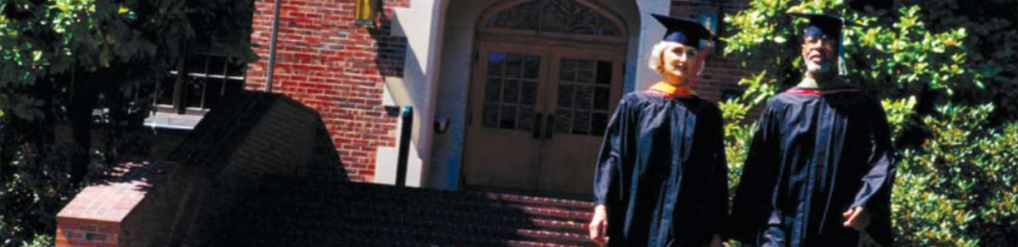

Presentations

International
- Off-Campus Life’s Director and Community Liaison presented at the United Kingdom Town and Gown Association conference in Nottingham, England, on Best Practices in Building Strong Town-Gown Partnerships.
- Off-Campus Life’s Community Liaison presented at the United Kingdom Town and Gown Association conference in Nottingham, England, on Community Living: An Innovative Classroom Experience.

National
    - The LSC Director of Operations presented a session titled “HVAC Systems: A Primer” at the ACUI Essentials of Facilities Management Conference.
    - The AVP for Student Affairs / Executive Director of the LSC served as a panel member for ACUI’s Experienced Leaders annual preconference institute.
    - The LSC served as the host site for ACUI’s 2017 national “Essentials of Facilities Management” training seminar, featuring the LSC renovation along with a variety of facility experts from across campus.
- Jason Foster co-presented with Erin Patchett and Julie Wallace Carr on “Pursuing a Terminal Degree” at the NIRSA Annual Conference in Washington, DC in February 2017.
- Erin Patchett, Matt McCarthy and Cindy Tse co-presented on “Fostering a Welcoming Culture: Strategies for Recreation Departments Starting Their Journey towards Inclusion” at the NIRSA Annual Conference in Washington, DC in February 2017.
- Erin Patchett, Jason Foster and Julie Wallace Carr co-presented on “Pursuing a Terminal Degree” at the NIRSA Annual Conference in Washington, DC in February 2017.
- Erin Patchett, Triniece Durst and Kim Rottet co-presented on “Gender Inclusive Practices” at the NIRSA Annual Conference in Washington, DC in February 2017.
- Erin Patchett and Heather Sanderson co-presented on “Research and Assessment Roundtable” at the NIRSA Annual Conference in Washington, DC in February 2017.
- Erin Patchett co-presented with members of the Equity, Diversity, and Inclusion Commission on “EDI Roundtable” at the NIRSA Annual Conference in Washington, DC in February 2017.
- Janelle Patrias co-presented with University of Texas-Austin prevention staff at the 2017 American College Health Association Annual Conference on Shaping Technology to Improve Student Well-Being.
- Martha Perrotin and Neal Luján presented Inclusive Excellence: Strategies to Balance Diversity and Consistency in a Card Environment, as a web conference, to the National Association of Campus Card Users (NACCU) on February 10, 2017, and to the National Association of College Auxiliary Services (NACAS) on February 16, 2017.
- Lindsay Sell served as a facilitator/presenter for Association of Fraternal Leadership and Values North American Interfraterity Conference Presidents Track in April 2017.
- Natalie Padrón served as a lead facilitator for the service trip for Kappa Alpha Theta Fraternity for Women in New Orleans, LA in June 2017.
- Natalie Padrón served as a facilitator for the Phi Delta Theta Kleberg Institute in Oxford, Ohio.
- How the RamCard Office implemented Disney's Approach to Quality Service was presented by Martha Perrotin at the 2017 National Association of Campus Card Users conference on April 3, 2017.
- LIVE ON: A Successful Campaign to Compete with the Off-Campus Market was presented by Ryan Blume, Mike DeJager & Tonie Miyamoto to the 2016 ACUHO-I Business Operations Conference.
- Stephanie Zee, Mitchell Holston and Jeffrey Mariano presented Model Minority Myth’s Impact on Anti-Blackness through Social Media and From Post-Grad to Seasoned Staff: Why Transitions Don’t Get Easier at NCORE.
- Greg Cherry presented Embracing Spirituality, Secularity, and Religion in Higher Education at ACPA.
- Mari Strombom co-presented A Dose of Dopamine with colleagues from 4240 Architecture at the ACUHO-I conference.
- Student Resolution Center staff were selected to present twice at the 2017 Association of Student Conduct Administrators Conference. One presentation provided information about CSU’s Impact Panel processes, and the other highlighted successful collaborations between CSU Conduct Services and Fort Collins Police Services.
- Conflict Resolution staff presented on Impact Panels at the National Association for Community and Restorative Justice Conference.
- Amy Robertson co-presented “First Year Survey and Reforming the Student Success Prediction Model” at the Higher Learning Commission conference: April, 2017).
- The Director of Outreach and Support Programs with the Collaborative for Student Achievement served as a presenter at:
  - the Financial Aid Conference for Campus Partners (FA16)
  - the Guided Pathways to Success Conference (SM17)
  - the NASPA Closing the Achievement Gap Conference (SM17)

Regional
- LSC Event Services presented “Event Management Tools” at the ACUI Regional Conference in Boulder, Colorado.
- Ben Burnham co-presented with Heather Foster and Ryan MacTaggart on "Building a thriving student staff: Creating a staff development program for your department" at the 2016 NIRSA CO/WY State Workshop in Boulder, CO in October 2016.
- Heather Foster co-presented with Ben Burnham and Ryan MacTaggart on "Building a thriving student staff: Creating a staff development program for your department" at the 2016 NIRSA CO/WY State Workshop in Boulder, CO in October 2016.
- Heather Foster presented the "Region V Connection Meeting" at the 2016 ND/MN State Workshop in September 2016, at the 2016 NIRSA CO/WY State Workshop in October 2016, and at the Western Canadian Conference in October 2016.
- Heather Foster co-presented the “Region V Connection Meeting” at the NIRSA Annual Conference in Washington, DC in February 2017.
- Brit Heiring presented on “Marketing 101: NoMo FOMO” at the 2016 NIRSA CO/WY State Workshop in Boulder, CO in October 2016.
- Four Apartment Life staff members presented at the CO/WY International Educators meeting in Colorado Springs on the experience of international graduate students in CO.
- Jacque Summers, Chris Miller and Danielle Wolfgang presented The Future of the Profession: Supporting Graduate Students in Residence Life at the AIMHO Conference.
- Kyle Oldham presented Being Black and LGB during BAACC Black History Month.
- Kyle Oldham presented Internalized Oppression for B/AACC Empowerment Conference.
- Stephanie Zee presented Beyond Thoughts and Prayers with Karissa Stolen from College of Business at the CSU Diversity Symposium and College of Business Social Justice Hour.
- Kyle Oldham was the Keynote Speaker at the Black Issues Forum.
- Kyle Oldham was the Keynote Speaker for the LEAD Conference.
- Kyle Oldham was the Keynote Speaker for the CSU High School Diversity Symposium.
- Kyle Oldham co presented on Trap of Diversity in Leadership with Pamela Graglia from INTO CSU at the CSU Diversity Symposium.
- Kyle Oldham co-facilitated The House We Live In: Race Power of Illusion with Vivian Ephraimson-Apt for the CSU Health Network for their January Retreat.
- Off-Campus Life’s Community Liaison presented at the Northwest Alcohol Conference, in Boise, ID, on Community Connections: When Town Meets Gown.
- Linda Stoddard presented on the Hospital Volunteer Model at the Western Association of Advisors for the Health Professions Regional Conference in May 2017.
State
    - Aaron Esobedo presented Building TRIO Bridges at Colorado State University. Colorado Chapter of ASPIRE’s Annual Conference.

Community
- Chris McKenzie Willenbrock presented Implicit Bias for the City of Fort Collins Supervisor’s Meeting.

Campus
    - “Do Something CSU!” presented by Hermen Diaz for Orientation and Transitions Programs – Transfer Students, Biomedical Sciences First-Year Seminar, CSU Admission Ambassadors, Front Range Community College, Admissions, TILT.
- Brit Heiring presented two sessions at the Division of Student Affairs Communications Bootcamp, which is open to the full Colorado State University campus. One presentation focused on best practices for social media and the second was a communication/marketing professionals panel.
- Jeffrey Mariano and Andre Roberts presented What Do You Meme That’s Not Funny? At the CSU High School Diversity Conference.
- Haley Wilson presented Gender is One Hell of a Drug at the CSU Diversity Symposium.
- Andre Roberts presented I’m Not Your Oreo at the B/AACC Empowerment Conference.
- Helena Gardner presented Why You Trappin’ So Hard - Motivation through Hip Hop Music at the B/AACC Empowerment Conference.
- Chris McKenzie Willenbrock presented The Assumptions We Make at the Diversity Symposium.
- Kate Wormus presented Abrazos: CSU Scholars in Nicaragua at the CSU Diversity Symposium.
- Brian Hayes was a Los Manos Conference Presenter (Youth Conference sponsored by Beta Gamma Nu).
- Sam Desta presented “Engaging Students in Service Learning Communities” at the National Learning Communities Conference.
Publications
- Students Against Hunger: An approach to food insecurity at a Large Public Land Grant University by Dr. Heather Novak and Dr. Jennifer J. Johnson.
- Witkowsky, P. Dinise-Halter, A. Long, S. & Yakaboski, T. (2017, In press) The educational experiences of non-traditional female students affairs graduate students. Journal of Student Affairs Research and Practice.
- Dinise-Halter, A. (2017). Positive professional development experiences for new professionals. College Student Affairs Journal.
- Zach Knight’s article, “Infusing your Policies with Assessment: A Balanced Approach,” was published in the 2017 Issue 1 of Perspectives.

Student Affairs Honors, Recognitions and Service

Staff and Students

International
- In June 2017, CityWorksEDU: Campus, City and Civic Engagement, new fall 3-credit and spring 2-credit course at CSU, was awarded the International Town and Gown Association’s Presidential Excellence Award.

National
- Erin Patchett served as the 2018 NIRSA Annual Conference Host Committee Chair.
- Loretta Capra served as the 2018 NIRSA Annual Conference Host Committee.
- Loretta Capra served as the 2016-2017 NIRSA Foundation, Legacy Society (Chair).
- Erin Patchett served as the 2016-2017 NIRSA Research and Assessment Committee (Chair).
- Erin Patchett served as the NIRSA Equity, Diversity, and Inclusion Commissioner.
- Rob Patchett served on the 2016-2017 National Intramural Recreational Sports Association Annual Conference Program Committee
- Adam Walsh served on the 2018 NIRSA Annual Conference Host Committee
- Brittany Wolf served on the 2018 NIRSA Annual Conference Host Committee
- Martha Perrotin was the recipient of the 2017 National Association of Campus Card Users New Professional Award. The New Professional Award is designated for an individual who has made a significant contribution to their institution, the industry and to the Association within a relatively short time.
- Zach Knight serves on the editorial board for Perspectives Magazine, a quarterly magazine published by the Association of Fraternity/Sorority Advisors.
- Natalie Padrón was honored as an outstanding fraternity/sorority advisor by the national Phi Delta Theta Fraternity.

Regional
- Ben Burnham (Campus Recreation) served as the 2016-2018 Colorado/Wyoming NIRSA State Leader.
- Brea Banks (CSU Health Network) – received the NASPA IV West New Professional Rising Star Award.
- CSU Health Network received the NASPA Region IV- West Award for Campus-Based Video/Computer System Software Award for YOU@CSU.
- Jonathan “JR” Rosario received the AIMHO Outstanding Entry-Level Professional Award.
- Kenzie Kitson received the AIMHO Outstanding Graduate Student Award
- Haley Wilson received the AIMHO Graduate Social Justice Action Award
- Demetrios Godenitz and Haley Richards received the National Academic Advising Association Region X People’s Choice Award for their presentation at the regional conference
- Jacqui Payne Stroud received the AIMHO Professional Staff Social Justice Award
State
- Student Resolution Center staff, Michael Katz, was recognized by Fort Collins Police Services and received the Meritorious Service Citation Award for his “hard work and dedication in maintaining the partnership between Fort Collins Police Services and CSU students.” The nomination stated, “As a result of Mr. Katz willingness to work with CSU students and the Fort Collins Police Department, there is a tremendous working partnership which couples education and enforcement to make the Fort Collins community a better and safer place to work.”

Campus
- Paige Jacobson received the Jack E. Cermak Advising Award.
- Erin Hammersley, Coordinator for Parent and Family Programs, received the DSA Quality Service Award.

Programs and Departments

National
- The CSU Bookstore was recognized as Collegiate Retailer of the Year by the National Association of College stores.
- Lory Catering received a bronze award for the online menu from the National Association of College and University Food Services (NACUFS).
- The Aspen Grille received a level one Green Restaurant Certification.
- Baseball, Climbing, Cycling, Disc Golf, Equine Polo, Men’s Ice Hockey, Men’s Lacrosse, Women’s Lacrosse, Rodeo, Shotgun Sports, Swimming, Tennis, Triathlon, Men’s Ultimate, Women’s Ultimate and Wrestling all qualified for and participated in post-season, Nationals play.
- CSU Student Case Management was awarded the NaBITA 2016 Best Practice/Institutional Impact Award .

